Ryerson University

EE8218: Parallel Computing

Distributed Password Recovery

Term Project Report
Maryam Bashardoust StID: 052398552

Martin Gerdzhev StID: 052501996
Fall 2008

- Introduction to Parallel Computing……………………………………………..………………………...3
- MPI (Message Passing Interface)……………………………………………………………………………5
  - MPI Gains and Constraints………………………………………………………………………….7
  - MPI and Memory Hierarchy……………………………………………………………………….8
  - Parallel Computer Memory Architectures………………………………………………….9
  - Parallel Programming Models……………………………………………………………………10
- Types of Encryptions……………………………………………………………………………………………..11
- Techniques on Password Cracking…………………………………………………………………………12
- Password Complexity…………………………………………………………………………………………….13
- Distributed Password Recovery……………………………………………………………………………..13
  - MD5 Hash Algorithm......................................................................................14
  - MD5 Process...................................................................................................14
  - MD5 Padding..................................................................................................15
- Installing MPICH2.......................................................................................................16
- Testing MPICH2 Installation.......................................................................................17
- Parallel Password Recovery Algorithm…………………………………………………………………..17
- Results…………………………………………………………………………………………………………………..21
- Conclusion..................................................................................................................28
- Appendix A – Source Code.........................................................................................29

- Introduction to Parallel Computing
Parallel computing is a form of computation in which many computation and calculation are carried out simultaneously. In this principle, large problems are often divided into smaller tasks that can be solved concurrently for high-performance computing. The sequential algorithms are constructed and implemented as a serial stream of instructions that are executed on a single Central Processing Unit (CPU) on one computer with one instruction execution at a time. Parallel algorithms, on the other hand, use multiple processing elements simultaneously to solve a problem, which is accomplished by breaking the problem into independent parts. Each part of the parallel algorithm is being executed by a processing element in parallel with the other parts. The processing elements can be diverse and include multiple computer resources such as a single computer with multiple processors, multiple networked computers, or a combination of both. Therefore however parallel algorithms are difficult to code than sequential algorithms, they offer high performance computing, high performance scalability, multiple execution at the same time, and less computing time for large problems.
The comparison between parallel computing and serial computing can be summarized as follow:
Serial computing:
- A problem is broken into a discrete series of instructions.
- Instructions are run on one computer with a single CPU.
- Instructions are executed one after another.
- One instruction may be executed at a time.
instructions
tN t2 t1
problem
CPU
Figure 1 – Serial Computation

Parallel computing:
- A problem is broken into discrete parts.
- These parts are run on multiple CPUs.
- These parts are executed concurrently.
- Further, each part is broken down into a series of instructions.
- Instructions from each part are executed on different CPUs simultaneously.
CPU
problem
instructions
CPU
problem
CPU
problem
tN t2 t1
Figure 2 – Parallel Computation

The restriction and limitation of traditional serial computing both physically and practically cause significant constraints to build fast serial computers. One restriction is transmission speeds in which the speed of serial computer depends on how fast data can move through hardware. The increase in speed needs the increase of processing elements, considering absolute limits are the copper wire transmission limit (9 cm/nanosecond) and the light speed (30 cm/nanosecond). Another restriction could be cost limitations, since making a single processor faster is increasingly expensive. And finally the last restriction that can be considered is limits to miniaturization. Knowing that processor technology allows an increasing number of transistors to be placed on a chip although with atomic-level or molecular components, reaching a limit depends on how small these components can be. We also can mention about the limitation on memory size and power usage, and heat problem.
Regarding to all limitations that we might face in serial computing, utilizing parallel computing can overcome these obstacles. The benefits of adopting parallel computing in solving problems can be presented as:
- High performance computation.
- Taking advantages of non-local resources by using computing resources on a wide area network (WAN) or Internet.
- Overcoming memory constraints, since every computer has finite memory resources and by using multiple computers the total amount of memory will increase.
- Cost saving by using multiple inexpensive computing resources instead of paying expensive cost for time on a supercomputer.
- Increasing the number of available resources by using multiple computers, since each computer has its own disk space, bandwidth and processing power.
- Decreasing the computation time, while multiple tasks are running at the same time.
- Frugality, with making use of every spare moment that computer's processor is inactive.

- MPI (Message Passing Interface)
MPI is an industry standard API specification designed for high performance computing on multi-processor machines and clusters of machines. It allows many computers to communicate with one another, it is used in computer clusters and supercomputers, and it offers a distributed memory programming model for parallel applications. Although the entire MPI API set is relative large containing more than 300 routines, many MPI applications can be programmed with less than a dozen of basic routines.
There are a number of MPI implementations coming from different research institutes and companies. The most popular one is MPICH which is quite often used as the code base for MPI implementations optimized for a specific platform or interconnect. In MPICH design, the entire API set is implemented and built on top of a small core set of low level device interconnect routines. This design architecture offers good portability across different platforms. One only needs to re-work the small core set of device interconnect routines to port or optimize MPICH for a new platform or interconnect.
Figure3 shows a pair of MPI send and receive routines to communicate a message:

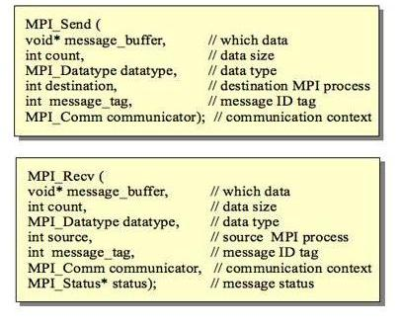
Figur3 - MPI send and receive

The first 3 arguments of both routines specify the location, data type and amount of the message. The fourth argument identifies the target process to communicate with. The fifth argument tag ID provides a further mechanism to distinguish between different messages. The sixth argument specifies the communication context. There is an additional argument in the receive routine to report the receiving status.
The MPI implementations are still evolving:
MPI-1:
- Supports the key features such as point to point and collective message communication with a communicator.
- A message can contain MPI data of primitive data types or derived (user-defined) data types.
- The message data content can be in packed or unpacked format.
- Supports interconnect topology.

MPI-2:
- Provides many advanced communication features such as remote memory access and one-side communication.
- Supports dynamic process creation/management and parallel IO.

- MPI Gains and Constraints
The benefits of applying MPI for parallel programming simply can be mentioned:
- MPI is portable and it allows any parallel algorithm to be expressed in terms of the MPI paradigm.
- Runs on both distributed and shared-memory systems with high performance in any environment.
- Allows explicit control over communication, leading to high efficiency due to overlapping communication and computation.
- Allows for static task handling.
- Data placement problems are rarely observed.
- Current implementations are efficient and optimized

In general MPI offers a good solution for parallel application on computer clustering, but it is also a difficult programming model for many developers:
- Application development is difficult; because re-fitting existing serial code using MPI is often a major undertaking, requiring extensive restructuring of the serial code.
- MPI has longer communication latency; the program core logic must be partitioned well to justify the distribution overhead. It is not an intuitive task to analyze and partition an application problem and map it to a set of distributed processes.
- Because of the complexity of interaction among many MPI processes, it is also quite challenging to debug and tune a MPI application running on a large number of nodes even with the right tools. The quality of MPI routine implementation may impose additional software development challenges.
- MPI performance depends on the underlying hardware platform and interconnect. In some extreme cases, the MPI application behaviour may be affected by heavy interconnect traffic.
- Reliability of large scale MPI application is a big issue. For many MPI implementations, a MPI program will stop working whenever a single computing node fails to respond correctly. Unfortunately when an MPI application runs for a long periods on thousands of computing nodes, the failure rate is no longer negligible.
- Dynamic load balancing is difficult to implement.
- It is less useful with fine-grained problems where communication costs may dominate.

- MPI and Memory Hierarchy
An application program will run faster, if most of its instruction and data memory accesses fall within the cache range. Because MPI is a distributed memory programming model, it usually can achieve good linear scalability for a large scale application. When a MPI application is partitioned to run on a large cluster of computing nodes, the memory space of each MPI process is reduced and the memory accesses could fall within the high performance range of the memory hierarchy. The non-uniform memory performance effect can apply to the other programming models including OpenMP.
At the current state of semiconductor technology and computer architecture, the dominant system performance factor is the memory hierarchy rather than CPU clock rate. Figure4 shows the non-uniform memory performance graph.
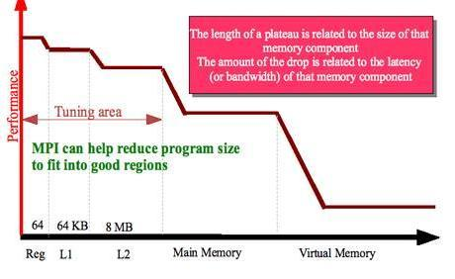
Figure4 - Non-Uniform Memory Performance

- Parallel Computer Memory Architectures
In general, three types of memory architecture exist for parallel computers:
    - Shared memory systems
Shared memory parallel computers vary widely, however the ability for all processors to access all memory as global address space is common between all of them. In this architecture, multiple processors can operate independently but share the same memory resources, so the changes in a memory location made by one processor are visible to all other processors. Shared memory machines can be divided into two main classes based upon memory access times: Uniform Memory Access (UMA) and Non-Uniform Memory Access (NUMA).
Memory
CPU
CPU
CPU
CPU
Figure5 – Shared memory architecture

    - Distributed memory systems
Distributed memory systems vary widely but share a common characteristic, which is the necessity of a communication network to connect inter-processor memory. Considering that processors have their own local memory, memory addresses in one processor do not map to another processor, so there is no concept of global address space across all processors. Moreover because each processor has its own local memory, it operates independently and the changes it makes to its local memory have no effect on the memory of other processors. Hence, the concept of cache coherency does not apply. When a processor needs access to data in another processor, how and when data is communicated should be explicitly defined. In this system, the network "fabric" used for data transfer varies widely, though it can be as simple as Ethernet.
Figure6 – Distributed memory architecture
Memory
CPU
Memory
CPU
Memory
CPU
Memory
CPU
network

    - Hybrid distributed-shared memory systems
The largest and fastest computers in the world today employ both shared and distributed memory architectures. The shared memory component is usually a cache coherent Symmetric Multiprocessing (SMP) machine in which processors on a given SMP can address that machine's memory as global. The distributed memory component is the networking of multiple SMPs that know only about their own memory not the memory on another SMP. Therefore, network communications are required to move data from one SMP to another. Current trends seem to indicate that this type of memory architecture will continue to prevail and increase at the high end of computing for the foreseeable future.
Figure7 – Hybrid memory architecture
network
Memory
CPU CPU

CPU CPU
Memory
CPU CPU

CPU CPU
Memory
CPU CPU

CPU CPU
Memory
CPU CPU

CPU CPU

- Parallel Programming Models
Parallel programming models are an abstraction above memory architecture and hardware. These models are not specific to a particular type of memory architecture or machine, and in fact they can be implemented on any underlying hardware. The following shows several parallel programming models that are commonly being used:
    - Shared Memory
    - Hybrid
    - Data Parallel
    - Threads
    - Message Passing
For the purpose of parallel programming, message passing model is being used for this project. Message passing model demonstrates a set of tasks that use their own local memory during computation, taking into account that these multiple tasks can reside on the same physical machine as well across an arbitrary number of machines. These tasks exchange data through communications by sending and receiving messages, therefore data transfer usually requires cooperative operations to be performed by each process for example a send operation must have a matching receive operation.

network
Task 0
data
Machine A
send(data)
Task 1
data
Machine B
receive(data)
Figure8 – Message Passing Model

- Types of Encryptions
Encryption makes data private, but not necessarily secure. To make data secure, the recipient of the data must be identified as the approved party which is usually accomplished by using digital signatures or certificates. In general, there three types of encryptions; Symmetric, Asymmetric, and Hybrid.
Symmetric Encryption:
Symmetric encryption or private-key encryption uses a secret key value to encrypt and decrypt the data. Both the sender and receiver need the same key in order to encrypt or decrypt. Although symmetric algorithms are generally fast, security associated with this type of encryption is hard to guarantee. Therefore the drawback to this type of system is that if the key is discovered, all messages can be decrypted. There are two types of symmetric algorithms, stream algorithms and block algorithms. The stream algorithms work on one bit or byte at a time, whereas the block algorithms work on larger blocks of data (typically 64 bits) such as Block Ciphers.
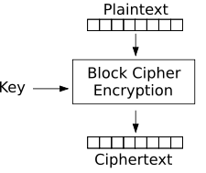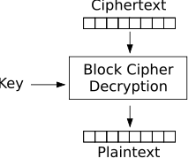
Figure9 – Block Cipher Encryption

Asymmetric Encryption:
Asymmetric encryption or public-key encryption uses separate keys for encryption and decryption which the decryption key is very hard to derive from the encryption key. The encryption key is public key so that anyone can encrypt a message. However, the decryption key is private key, so that only the receiver is able to decrypt the message. This type of encryption is very secure; however it is somewhat slower than symmetric encryption. It is common to set up "key-pairs" within a network so that each user has a public and private key. The public key is made available to everyone so that they can send messages, but the private key is only made available to the person it belongs to. The example of asymmetric encryption can be Public-key Cryptography and also MD5 hash algorithm which is being used for this project as the base encryption method.

Hybrid Encryption:
Hybrid cryptosystems incorporate aspects from both symmetric and asymmetric encryption schemes. These hybrid systems amalgamate the convenience of public-key with the efficiency of private-key. A hybrid system is basically broken down into two separate cryptosystems; the key encapsulation system and the data encapsulation system. The data encapsulation system which holds the message data is encrypted and decrypted by means of private-key encryption, meaning that both the sender and receiver have the same key. The key encapsulation system on the other hand uses public-key encryption as a means to encrypt/decrypt the key data. This key data, obtained through public-key encryption, is used as the private-key for the data encapsulation system.

- Techniques on Password Cracking
Password cracking is the process of recovering passwords from data that has been stored in or transmitted by a computer system. The purpose of password cracking might be to help a user recover a forgotten password (though installing an entirely new password is less of a security risk, but involves system administration privileges), to gain unauthorized access to a system, or as a preventive measure by system administrators to check for easily crackable passwords. There are three basic types of password cracking tests that can be automated with tools:
  - Dictionary: A file of words that is run against user accounts, and if the password is a simple word, it can be found pretty quickly.
  - Hybrid: A common method utilized by users to change passwords is to add a number or symbol to the end. A hybrid attack works like a dictionary attack, but adds simple numbers or symbols to the password attempt.
  - Brute force: The exhaustive and most time-consuming method, but comprehensive way to crack a password. Every possible combination of characters is tried until the password is broken.
The parallel program for our project employs Brute force approach to discover the plaintext password. Section 9 of this report contains the detailed information of the parallel algorithm for password recovery.

- Password Complexity
Generally, the longer a password is, the more difficult it is to crack. Later on in the report, the result diagrams from running our parallel algorithm to recover the password confirm that for longer passwords the time taken by the algorithm is much more than small passwords. The number of possible password combinations for a given set of allowed characters follows the rule of length of allowed characters to the power of length of password. This procedure is used to calculate all possible password combinations of a certain length, along with a determined set of characters.
For example a correct four digit PIN code, where the allowed digits are [0-9], will exist within the interval {0000, 0001, ..., 9999} as follows:
Allowed digits[0-9] ^ PIN-code[****] <=> 10^4 = 10,000 combinations
Or [a-z, A-Z, 0-9] ^ password_length (6) <=> 62^6 = 56,800,235,584 combinations

- Distributed Password Recovery
Distributed password recovery offers a comprehensive solution for recovering passwords through using all the available computing power of every computer in the LAN or WAN. The general parallel algorithm for password recovery needs to be distributed and run on the required computers in the network where this algorithm uses brute force approach to try to recover the password. This system provides the ability of breaking complex passwords, recovering strong encryption keys and unlocking documents in a production environment. Distributed password recovery can be applied to:
- OpenDocument (ODF): documents, spreadsheets, presentations, graphics/drawing, formulae (password recovery)
- UNIX users' passwords (password audit/recovery)
- MD5 hashes (plaintext recovery)
- WPA and WPA2 passwords (password recovery)

  - MD5 Hash Algorithm
MD5 (Message-Digest algorithm) is a widely used asymmetric algorithm and partially insecure cryptographic hash function with a 128-bit hash value. As an Internet standard (RFC 1321), MD5 has been employed in a wide variety of security applications, and is also commonly used to check the integrity of files. An MD5 hash is typically expressed as a 32 digit hexadecimal number.
MD5 is a compact digital signature for an arbitrarily long stream of binary data. An ideal message digest algorithm would never generate the same signature for two different sets of input, but achieving such theoretical perfection would require a message digest as long as the input file. Practical message digest algorithms compromise in favour of a digital signature of modest size created with an algorithm designed to make preparation of input text with a given signature computationally infeasible. Message digest algorithms have much in common with techniques used in encryption, but to a different end; verification that data have not been altered since the signature was published.

  - MD5 Process
The main MD5 algorithm operates on a 128-bit state, divided into four 32-bit words, denoted A, B, C and D which are initialized to certain fixed constants. It takes as input a message of variable-length and produces as output a fixed-length 128-bit "fingerprint" or "message digest" of the input. The main algorithm breaks the input message into 512-bit blocks and then operates on each 512-bit message block in turn, each block modifying the state. The message is padded so that its length is divisible by 512. The processing of a message block consists of four similar stages, termed rounds; each round is composed of 16 similar operations based on a non-linear function F, modular addition, and left rotation.
Figure10 shows the way that MD5 functions on a prepared message blocks, where <<< denotes a left bit rotation by s places (s varies for each operation) and denotes addition modulo 2³².

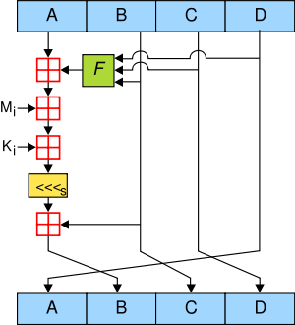
Figure10 – MD5 algorithm

  - MD5 Padding
As it is mentioned, the input message is padded so that its length is divisible by 512 in order to be broken to 512-bit blocks by Md5 algorithm. For the purpose of padding, first a single bit, 1, is appended to the end of the message, this is followed by as many zeros as are required to bring the length of the message up to 64 bits less than a multiple of 512. The remaining bits are filled up with a 64-bit integer representing the length of the original message in bits.

- Installing MPICH2
- Get source code from: http://www.mcs.anl.gov/research/projects/mpich2/downloads/index.php?s=downloads
- Unpack downloaded file mpich2.tar.gz:
tar xfz mpich2.tar.gz
- Create install directory
mkdir ~/mpich2-install
- Configure MPICH2:
configure \-prefix=~/mpich2-install |& tee configure.log
- Build MPICH2:
make |& tee make.log
- Install the MPICH2 commands:
make install |& tee install.log
- Add the bin folder to the PATH
- At Ryerson EE department you must do this:
- Edit .myzshrc and add the following:
PATH=~/mpich2-install/bin:$PATH
export PATH
- This will set the path variable so that all the mpi binaries would be accessible directly.
- It is necessary for running the programs on all the machines.
- Check that everything is in order at this point by doing:
which mpd
which mpicc
which mpiexec
which mpirun
- Create a file .mpd.conf in home directory:
touch .mpd.conf
chmod 600 .mpd.conf
- Add a secretword to the file:
echo “secretword=mr45-j9z” >.mpd.conf
- Add host names to config file mpd.hosts
- To avoid the password prompt:
cd ~/.ssh
ssh-keygen -t rsa
cp id_rsa.pub authorized_keys

- Testing MPICH2 Installation
- Start the mpi daemon
mpdboot -n 5 -f mpd.hosts
- Test the ring:
mpdtrace
- Test how long it takes a message to circle this ring with:
mpdringtest
- Exit All mpd daemons
mpdallexit

- Parallel Password Recovery Algorithm
As we mentioned in section 6, distributed password recovery algorithm provides a comprehensive solution for recovering passwords by means of distributing the algorithm on all the available machines in a computer network. The computing power in the network consists of a root computer and any number of available computers running in parallel. The system works by way of splitting the password over multiple computers that can be accomplished as is shown in figure11 and grants the ability of breaking complex passwords and recovering strong encryption keys in a production environment.

Master Controller

MinLen = 0
MaxLen = 5
CharCount = 95

MinLen = 6
MaxLen = 6
CharCount = 95

MinLen = 7
MaxLen = 7
CharCount = 95

Figure11 – Example of splitting a password among multiple computers

The parallel password recovery algorithm is based on the Brute Force approach to discover the plaintext password, which will be run on all the computers in the network. First through the root computer, we read the MD5 encoded password from a file. Later, the root computer transmits the encoded password, a set of allowed characters and a specific subset to every computer in the system. The set of allowed characters can include lowercase characters, uppercase characters and digits. In general, the root computer sends the following to all the available computers in the network:
- The MD5 hash that contains the encoded password.
- The allowed set of characters that is being used to try all the possible combinations of the password.
- Two numbers for starting and ending positions that translate to character combinations to try that are unique for each computer.
Each computer receives these three parameters and starts running the password recovery algorithm. This password recovery program uses MD5 algorithm to generate a hash from the input subset and produce an encoded result. Afterwards it compares the encoded result with the actual encoded password. The time it finds the match, it will send the decoded password to the root computer. Subsequently the root computer sends a stop message to the rest of the computers in the network. Below is a simple example of how the algorithm works.

Example:
Root reads the MD5 hash from a file and broadcasts it to all machines.
- 32-bit hash in HEX 128-bit encryption
A6d8fbb98ac4e3f10…b
Then sends the set of allowed characters – e.g. [a-zA-Z]
- The allowed set
a b c d ... z A B C D ... Z
1 2 3 4 ... 26 27 ... 52

Then sends start and position numbers to each computer divided equally. The total number is based on the possible combinations of the allowed characters up to a specified length.
- Position numbers
Computer 1 Computer 2 …
1, 64 65, 128

a b c d ... z A B C D …Y Z

1 2 3 … 51 52

am an ao … aZ

65 66 … 104

…

aa ab ac … al

53 54 … 64

ba bb bc … bx

105 106 … 128

…

Each of these character combinations is encoded with the MD5 algorithm and compared with the sent encoded hash. If the 2 hashes match then the character combination that produced the hash is the password. It is then send to the server and the program terminates.

An illustration of how the algorithm works is shown in figure12.

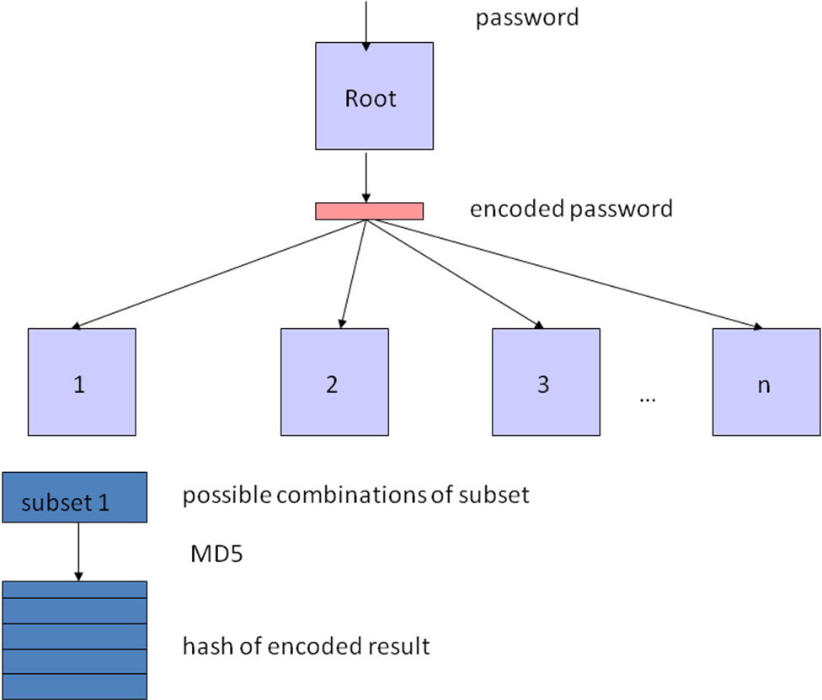

Figure12 – Distributed password recovery system

- Results
We ran a series of tests where we encoded a password with MD5 and then we ran our program by specifying the maximum password length it should look for. We used the MD5 library provided with XYSSL encryption library for C and the Message Passing Interface. In the first series of tests we wanted to find the worst case scenario (the password is not found or it is the last possible combination tested) when looking for passwords with up to one, two, three, four, five, and six characters in length. The allowed character set included lower-case and upper-case letters. In our tests we ran our program on 2, 6, 11, 21, and 41 machines. One of the machines was a root machine which was assigning the work to the other machines and was used for synchronization. The remaining machines were doing the computation. So when two machines are used, only one machine is doing the computation. With six machines, five are doing the computation and so forth.
The results of tests with length of one and two characters are not included because the time it takes on any number of nodes was under one second. Below are our findings with three, four, five, and six characters.
143,364 combinations

With a password of up to 3 characters there are 143,364 possible combinations. The total time it took was approximately one second for all combinations tested which was probably due to the initial communication cost. The only combination that took more than one second was with two nodes.

7,454,980 combinations

When the password length was increased to four characters and 7,454,980 possible combinations we can see more clearly the difference that more computers make. It took about one minute with 2 computers while it only took about 2 seconds with 41 computers.

387,659,012 combinations

With a password of up to 5 characters and 387,659,012 combinations with two nodes it took about 50 minutes. For the same test it took roughly 10 minutes with 6 nodes, 5 minutes with 11 nodes, two minutes 40 seconds with 21 nodes and only minute forty seconds with 41 computers. From this result we can clearly see that when we double the number of nodes we are decreasing the run time by half.
20,158,268,676 combinations

With a password of up to 6 characters and 20,158,268,676 combinations due to time restrictions, we ran the test only with 41 nodes and estimated the time it would take with 21, 11, 6, and 2 nodes based on our findings from the previous test. It took 73.5 minutes for all possible combinations with 41 nodes, while with 2 nodes it would take 1176 minutes or 19.6 hours.
Next we ran tests with two passwords of three, four, five, and six characters in length to show the performance of the algorithm with real data. Our findings are shown below.

With a password “abc” all computer combinations found the password in one second or less.

With a password “BaR” we can see similar results – ones second or less to find the password.

With a password “DIME” we can see that it takes about 30 seconds with 2 nodes, 10 seconds with 6 nodes, 5 seconds with 11 nodes, 2 seconds with 21 nodes and under 1 second for 41 nodes. These results can be explained with the way the partitioning works and how one computer might get a starting point which is closer to the password that we are looking for and therefore completes sooner.

With a password “dime” all computer combinations find the password in 5 seconds or less. With our algorithm “dime” comes a lot sooner than “DIME” in the character combinations and therefore is found faster as with 6 nodes it finds the password in under 1 second which means that it was one of the first combinations that were tried.

When increasing the password length to 5 characters with “TestI” we can see again that it takes much longer to find the password with 2 nodes than with more nodes.

With the password “testI” we again see that the more computers that are added, the faster the password is found.

N/A

Increasing the password to 6 characters with “Martin” we can see that with 41 nodes the password was found within 30 minutes. It took roughly 94 minutes with 11 nodes and 21 nodes which can be attributed to the very similar partitioning of the character sets so close to the actual password. With 6 nodes it took about 6 hours. We did not test with 2 nodes due to time limitations as it would take somewhere between 6 hours and 19.6 hours.

- Conclusion
From our results we can conclude that increasing the number of nodes, will decrease the time proportionally. Ten computers will find the password twice as fast as five computers.
Another finding was that there is no limitation for the number of nodes that can be used. In our algorithm the communication cost is very minimal and it grows linearly. Only four messages are sent per computer and then there is no communication until the password is found or a computer doesn’t find it in the assigned character set.
The scalability of the algorithm allows for the recovery of longer passwords faster by using a large set of computers.
We also found that our algorithm works best with computers that have similar performances as it divides the workload equally. This means that if the computers have different performances, the faster computers would finish their sets faster and would sit idle while the slower computers still compute. The algorithm could be adapted so that it will poll for the performance capabilities of each computer and then assign the workload based on that to maximize the processor utilization.
Our algorithm works with MD5 but can be easily extended to work with a range of encryption schemes by providing the required libraries.
- Appendix A – Source Code
md5server.c

#include <stdio.h>
#include <sys/types.h>
#include <time.h>
#include <string.h>
#include <stdlib.h>
#include <mpi.h>
#include <math.h>
#include <inttypes.h>
#include "md5.h"

typedef struct
{
long long int quot; /* quotient */
long long int rem; /* remainder */
} lldiv_t;

int getPosition(char aChar, char * array);
void getBaseNNumber(long long int number, int base, int *length, int * array );

int main (int argc, char * argv[])
{
int i, j;
char output[33];
md5_context ctx;
unsigned char buf[100];
unsigned char md5sum[16];
FILE * f;
FILE * output_file;
int node;
int size;
int rank;
MPI_Request recv_req[50];
MPI_Status status;
int num_chars;

if (argc <4)
{
printf("Usage %s -f file max_length\n",argv[0]);
exit(1);
}

else if (argc == 4 && strcmp(argv[1],"-f")==0)
{
num_chars = atoi(argv[3]);
MPI_Init(&argc,&argv);
MPI_Comm_rank(MPI_COMM_WORLD, &rank);
MPI_Comm_size(MPI_COMM_WORLD, &size);
if (rank ==0) //root
{
char char_set[53] = {'a','b','c','d','e','f','g','h','i','j','k','l','m','n','o','p','q','r','s','t','u','v','w','x','y','z','A','B','C','D','E','F','G','H','I','J','K','L','M','N','O','P','Q','R','S','T','U','V','W','X','Y','Z','\0'};
long long int chars_per_node = 1;
long long int current;
long long int remainder;
long long int temp_counter=0;;
char current_word[size-1][num_chars+1];
time_t start, stop;
double diff;
int index;
int found = -1;

start = time(NULL);

if( ! ( f = fopen( argv[2], "rb" ) ) )
{
perror( "fopen" );
return( 1 );
}

fscanf(f,"%s\n",buf);
fclose(f);
printf("Read %s\n",buf);
printf("Number of slaves = %d\n",size-1);
for (i=0;i<num_chars;i++)
{
chars_per_node = chars_per_node * strlen(char_set) ;//+i*strlen(char_set);
temp_counter += chars_per_node;
}
temp_counter -= chars_per_node;
chars_per_node+=temp_counter;
printf("Total possible combinations for length %d is %lld\n",num_chars, chars_per_node);
remainder = chars_per_node % (size-1);
printf("Initial remainder: %lld\n",remainder);
chars_per_node = chars_per_node/(size-1);
printf("Chars per node: %lld\n", chars_per_node);
MPI_Bcast ( (void *)buf, 33, MPI_CHAR, 0,MPI_COMM_WORLD );
printf("Hash broadcasted\n");
MPI_Bcast ( (void *)char_set, sizeof(char_set), MPI_CHAR, 0,MPI_COMM_WORLD );

for (i=1;i<size; i++)
{
current = chars_per_node*(i-1);
MPI_Send(&current, 1, MPI_LONG_LONG_INT, i, 1, MPI_COMM_WORLD);
if (i==size-1)
current = chars_per_node*(i)+remainder;
else
current = chars_per_node*(i);
MPI_Send(&current, 1, MPI_LONG_LONG_INT, i, 2, MPI_COMM_WORLD);

}

/* Receive a message from all other processes */
for (i=1; i<size; i++)
{
MPI_Irecv (&current_word[i-1], num_chars+1, MPI_CHAR, i, 3, MPI_COMM_WORLD, &recv_req[i]);
}
/* While the message is delivered, we could do computations here */

for (i=1; i<size; i++)
{
/* Wait until at least one message has been received */
/* Request array start from element 1, because we don't receve */
/* any message from process 0 (our selves) */
MPI_Waitany(size-1, &recv_req[1], &index, &status);
if (strlen(current_word[status.MPI_SOURCE-1])==0)
{
/* Print out which process we received a message from */
printf("Node %d didn't find the password %s\n", status.MPI_SOURCE, current_word[status.MPI_SOURCE-1]);
}
else
{
found = 0;
break;

}
}

stop = time(NULL);
diff = difftime(stop, start);

if( ! ( output_file = fopen( "result.txt", "a" ) ) )
{
perror( "fopen" );
return( 1 );
}
//Write the result to file
if (found==0)
{
printf("NODE %d FOUND THE PASSWORD: %s\n",status.MPI_SOURCE, current_word[status.MPI_SOURCE-1]);
printf("Elapsed time: %f seconds\n", diff);
fprintf(output_file, "%s - %s time elapsed: %f seconds, number of nodes: %d\n", buf, current_word[status.MPI_SOURCE-1], diff, size);
}
else
{
printf("PASSWORD NOT FOUND\n");
fprintf(output_file, "%s - PASSWORD NOT FOUND with maximum %d characters, time elapsed: %f seconds, number of nodes: %d\n", buf, num_chars, diff, size);
}
fclose(output_file);
printf("DONE\n");
//Stop all the other processes
MPI_Abort( MPI_COMM_WORLD, 0 );
MPI_Finalize();
exit(0);
}
else //slaves
{
char input_hash[33];
char result_hash[33];
char allowed_chars[80];
long long int start_end[2];
char tempArray[3];
char last_char;
long long int difference;
long long int k;
char current_word[num_chars+1];
char end_word[num_chars+1];
int baseNArray[num_chars] ;
int index;
long long int remainder;
int length;
int allowed_length;
int pos;
long long int percentage;

printf("starting node: %d\n", rank);
MPI_Bcast((void *)input_hash, 33, MPI_CHAR, 0, MPI_COMM_WORLD);
MPI_Bcast ( (void *)allowed_chars, 80, MPI_CHAR, 0,MPI_COMM_WORLD );

allowed_length = strlen(allowed_chars);
last_char = allowed_chars[allowed_length-1];
MPI_Recv(&start_end[0], 1, MPI_LONG_LONG_INT, 0, 1, MPI_COMM_WORLD, &status);
printf("received start point: %lld on node %d\n", start_end[0], rank);
MPI_Recv(&start_end[1], 1, MPI_LONG_LONG_INT, 0, 2, MPI_COMM_WORLD, &status);
printf("received end point: %lld on node %d\n", start_end[1], rank);

difference = start_end[1] - start_end[0];

getBaseNNumber(start_end[1],allowed_length, &length, baseNArray);

for (k=0;k<length;k++)
{
end_word[k] = allowed_chars[baseNArray[k]];
}
end_word[length]='\0';
getBaseNNumber(start_end[0],allowed_length, &length, baseNArray);

for (k=0;k<length;k++)
{
current_word[k] = allowed_chars[baseNArray[k]];
}
current_word[length]='\0';
//Array is initialized
index = length-1;
printf("Starting word: %s, Ending word: %s, node: %d\n",current_word,end_word, rank);
i=0;
percentage = difference/100;
for (k=0;k<difference;k++)
{
if (k % percentage==0)
{
printf("Node %d done %d%\n",rank,i);
i++;
}
md5_starts( &ctx );

md5_update( &ctx,current_word,strlen(current_word));

md5_finish( &ctx, md5sum );
sprintf(result_hash,"\0");
for( j = 0; j < 16; j++ )
{
sprintf(tempArray, "%02x", md5sum[j] );
strcat(result_hash,tempArray);
}
if (strcmp(result_hash, input_hash)==0)
{
printf("FOUND PASSWORD AT ITERATION %d\n",k);
MPI_Send((void *)current_word, num_chars+1, MPI_CHAR, 0, 3, MPI_COMM_WORLD);
break;

}

if (current_word[index]==last_char)
{
//Loop to previous elements
for (j=index;j>=0;j--)
{
if (current_word[j]==last_char)
{
current_word[j] = allowed_chars[0];
if (j==0)
{
//length must increase by one
index++;
current_word[index]= allowed_chars[0];
current_word[index+1] = '\0';
break;
}
}
else
{
current_word[j] = allowed_chars[getPosition(current_word[j],allowed_chars)+1];
break;
}
}
}
else
{
pos = getPosition(current_word[index],allowed_chars)+1;
current_word[index] = allowed_chars[pos];
}
}

MPI_Comm_size(MPI_COMM_WORLD, &size);

sprintf(current_word,"\0");
MPI_Send((void *)current_word, num_chars+1, MPI_CHAR, 0, 3, MPI_COMM_WORLD);

MPI_Finalize();
printf("%d DONE\n",rank);

}
}
return (0);
}

int getPosition(char aChar, char * array)
{
int i;
for (i=0; i<strlen(array); i++)
{
if (array[i]==aChar)
return i;
}
return -1;
}

void getBaseNNumber(long long int number, int base, int *length, int * array )
{
int baseNNumber[20];
int index = 0;
int i, remainder;
long long int temp;

do
{
remainder = number % base;

baseNNumber[index] = remainder;
if (index>0)
baseNNumber[index]--;
index++;
}
while ((number = number/base)!=0);
*length = index;
for (i=0;i<index;i++)
{
array[i] = baseNNumber[index-1-i];
}
}

