Follow the steps to install Cygwin

---------------------------------------------

- Go to http://www.cygwin.com/

- Click the Install or Update Icon

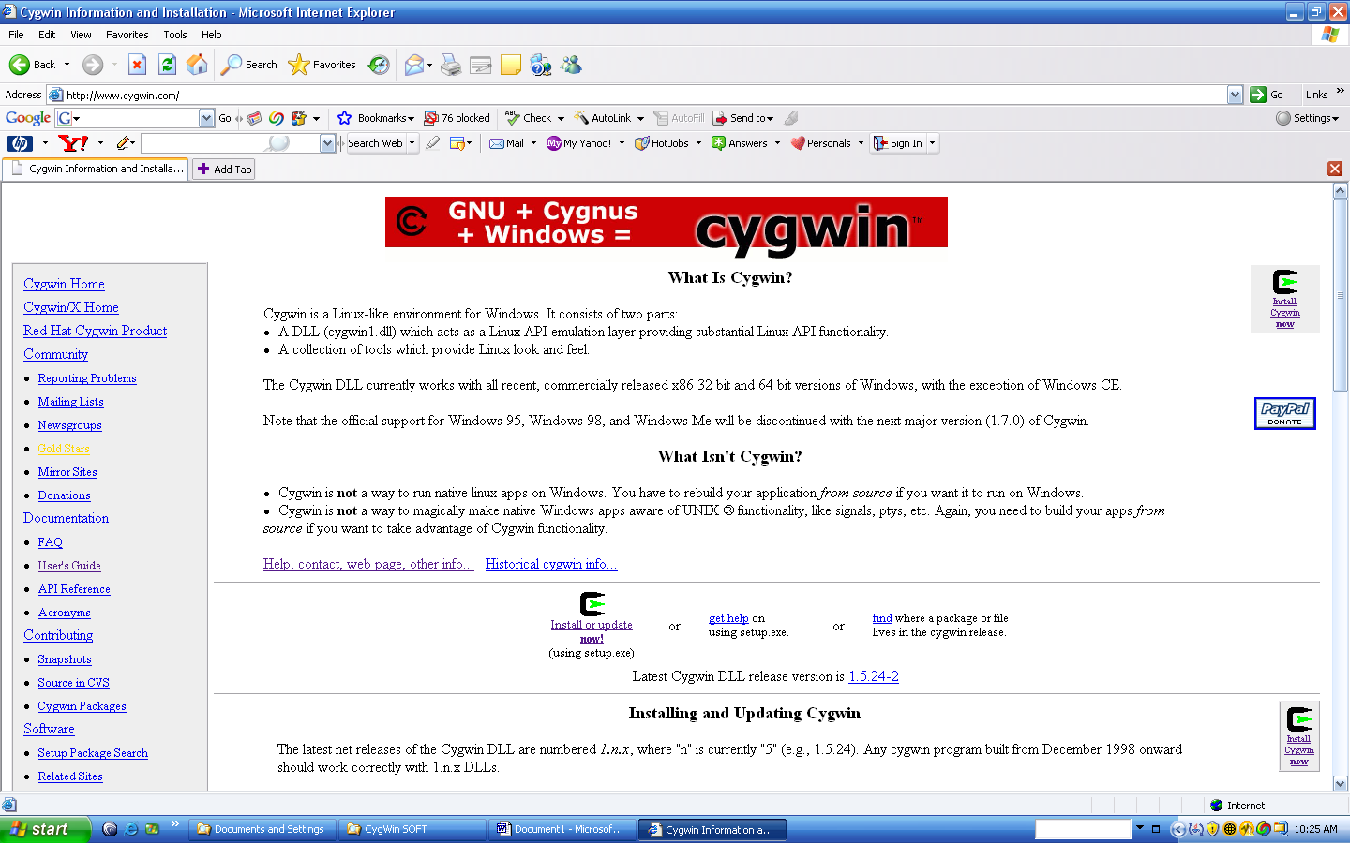

- Choose RUN from the following window.
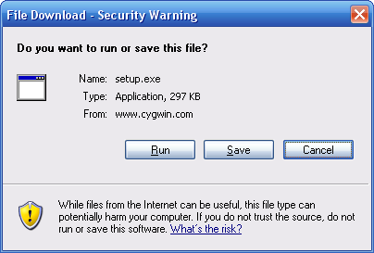

- Choose RUN again from the following window (If it pops up)
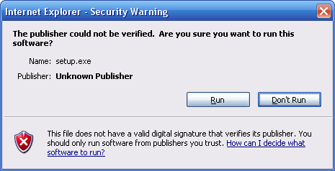

- Choose NEXT from following window

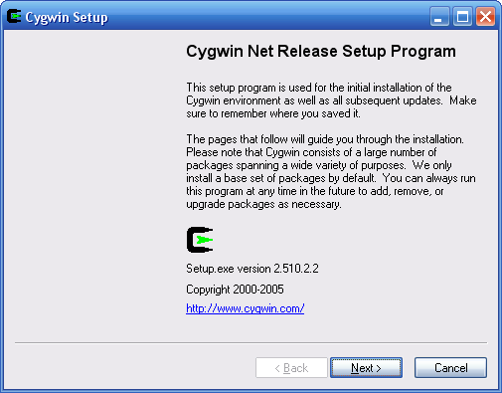

- Choose Install from Internet option and click NEXT button from following window .

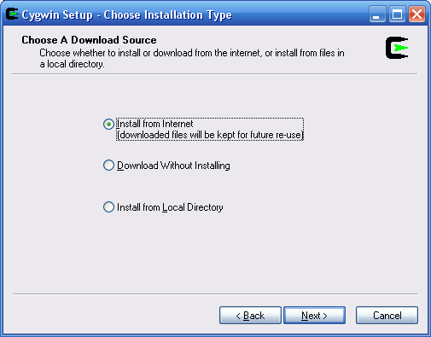

7. Enter the PATH for Cygwin software and keep default selections for all other options as shown below. And click NEX to continue

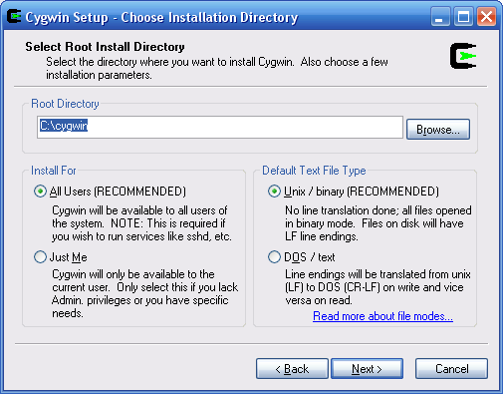

- Select a folder where you want to save a copy Cygwin installation files in the following window.

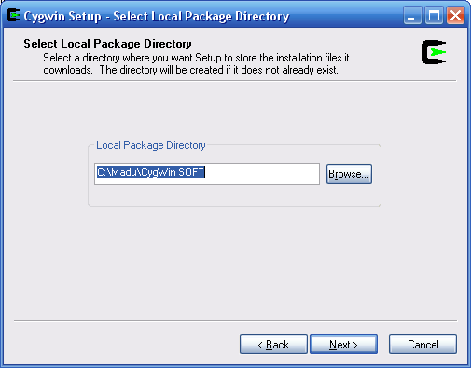

- Choose your connection type.

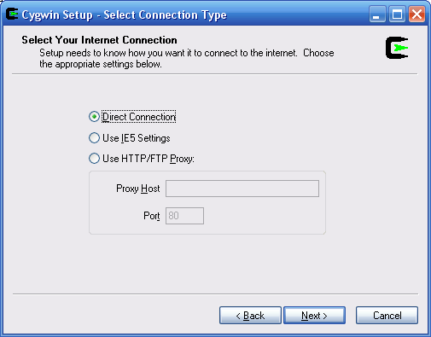.

- Select the nearest downloading website from the following window.

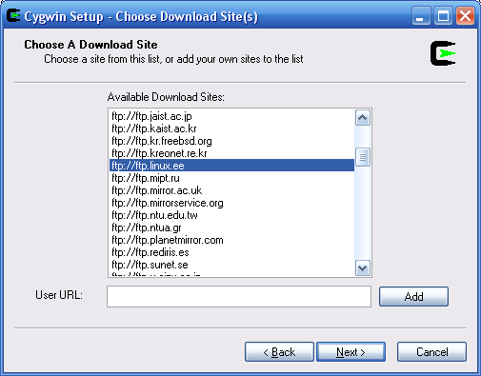

- By default Cygwin installation will not contain some of the additional utilities that we need in order to run GCC for Simplescalar. So to install these extra utilities, make sure that you have included Devel following window (Just click once to change it from default to install) and click NEXT.

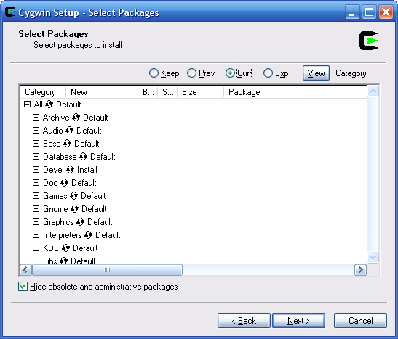

12 Click Finish.

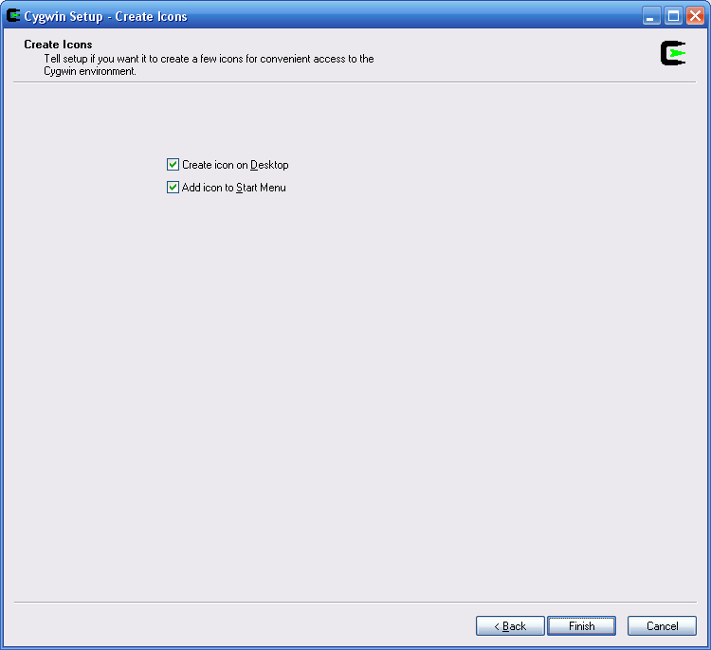

- After successful installation of Cygwin. Open Cygwin and type “make” command as shown in the following window.

NOTE: If you get “make: *** No targets specified and no makefile found. Stop.”, that means all the additional utilities also installed successfully. If you get message such as “bash: make: command not found” that means either you haven’t selected “Devel” tools while installing Cygwin or errors occurred while installing the software. So you may need to re-install Cygwin again including “Devel”.

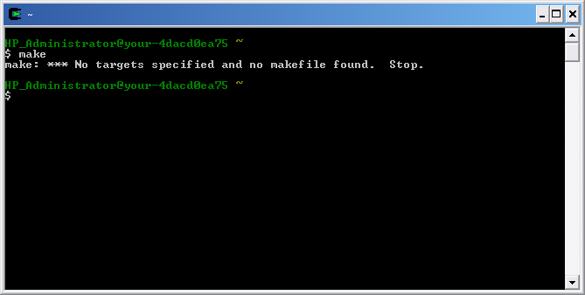

Cygwin installation is complete.

