Department of Computer and Electrical Engineering

PROJECT REPORT
Parallel Implementation
of Lee Algorithm
By:
Drago Ignjatovic
Arayeh Norouzi
Owojaiye Oluwaseun

EE8218: Parallel Computing
Submitted to:
Dr. Nagi Mekhiel

April 2010

Abstract

Lee's algorithm is a path finding algorithm and one possible solution for maze routing, which is often used in computer-aided design systems to route wires on printed circuit boards and . This report discusses the parallelization of Lee algorithm which can be used in certain contexts to improve its efficiency and processing time. Lee algorithm is parallelized and implemented on several processing units. Our algorithm parallelizes the front wave expansion scheme and performs front wave expansions concurrently, thus increasing the processor utilization and decreases the processing time. This however, is carried out using single-layer routing.

Table of Contents
Abstract 2
1. Introduction 4
2. Maze Routing Algorithm 5
3. Lee algorithm 5
3.1 Applications 5
3.2 Strengths and Weaknesses 5
3.3 Description 6
3.4 Lee algorithm in action 7
4. Mapping Lee Algorithm onto Parallel Architectures 10
5. Parallel Implementation 11
5.1 Sequential Flow chart for Lee Algorithm 12
5.2 Parallelized Flow chart for Lee algorithm 13
6. Results and Findings 14
7. Final Results 20
8. Conclusion 21
9. References 22
Appendix 23

Introduction

Routing is the task of finding a set of connections that will wire together the terminals of different modules on a printed circuit board or VLSI chip. Each connection connects a source terminal to a destination terminal. The Maze Routing algorithm is an algorithm to find connections between the terminals and the Lee algorithm is one possible solution for Maze routing problems. Lee algorithm searches for the shortest path between two terminals and guarantees to find a route between two points if the connection exists. This algorithm also guarantees the shortest path between the source and the destination terminals. Routing algorithms can be applied to automated wiring, global routing, detailed routing, CAD and other problems such as robot path planning.

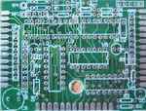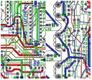
Fig 1. Printed Circuit Board – Ref [2]
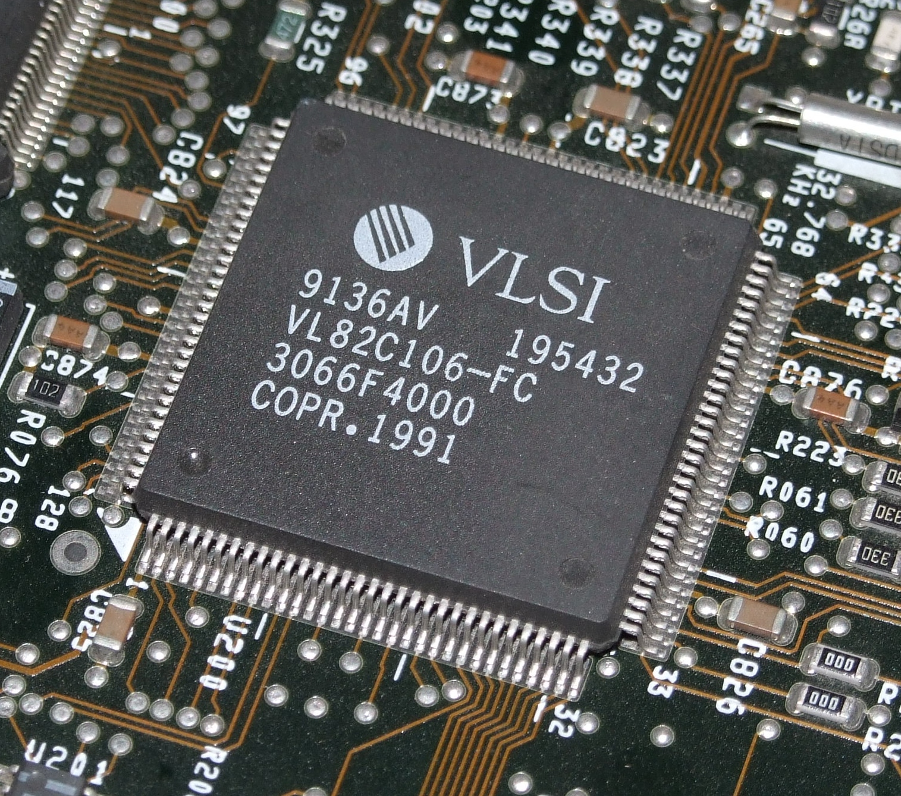
Fig 2. VLSI chip – Ref [7]

Maze Routing Algorithm

Maze routing algorithm tries to find the shortest path between two points in a maze for a single wire if such a path exists. In this scheme the source cell sends messages to its four neighbors. The message propagates in the form of a wave to other nodes. The first wave front that reaches the destination determines the connecting path. There are two phases in this algorithm. In the first phase nodes are labeled with their distances from the source. In the next phase distances are used to trace from sink to source choosing a path with the least distance to the source.

Lee algorithm

Lee algorithm is one possible solution for Maze routing problems. This algorithm represents the routing layer as a grid, where each grid point can contain connections to adjacent grid points.

Applications

- VLSI routing
- Computer Aided Design (CAD)
- Robot Path planning
- Global and detailed routing

Strengths and Weaknesses

Strengths:
- Guarantee to find connection between 2 terminals if it exists.
- Guarantee minimum path.
Weaknesses:
- Requires large memory for dense layout
- Slow

Description

It searches for a shortest-path connection between the source and destination nodes of a connection by performing a breadth-first search and labeling each grid point with its distance from the source. This expansion phase will eventually reach the destination node if a connection is possible. A second trace back phase then forms the connection by following any path with decreasing labels. This algorithm is guaranteed to find the shortest path between a source and destination for a given connection. However, when multiple connections are made one connection may block other connections. The wave expansion marks only points in the routable area of the chip, not in the blocks or already wired parts. To minimize segmentation it is best to keep in one direction as long as possible.
1) Initialization
- Select start point, mark with 0
- i := 0
2) Wave expansion
- REPEAT
- Mark all unlabeled neighbors of points marked with i with i+1
- i := i+1
UNTIL ((target reached) or (no points can be marked))
3) Backtrace
- go to the target point
REPEAT
- go to next node that has a lower mark than the actual node
- add this node to path
UNTIL (start point reached)
4) Clearance
- Block the path for future wirings
- Delete all marks

Although Lee algorithm guarantees to find the connection between 2 terminals if it exists and also it guarantees minimum path, it requires large memory for dense layout and it is slow. The time and space complexity for this algorithm for an M by N grid is O(MN).
  - Lee algorithm in action
(Figures 3 to 6 shows demonstration)
- Routing layer is represented as a grid
- Each grid point contains connections to adjacent grid points.
- Search for a shortest-path connection between the source and destination by:
- Performing a breadth-first search
- Labeling each grid point with it's distance from the source
- Trace-back phase forms the connection by following paths with decreasing labels.

In figure 3, source and destination nodes are chosen in the grid. In the expansion phase as shown in figure 4, waves start to propagate and expand from source “S” to destination “T” terminals. When target is reached, the trace back phase is ignited. As shown in figure 5, the algorithm starts from the destination point and looks for nodes with the least label to add to the chosen path to obtain the shortest path between the nodes. In figure 6, trace back is complete and the connection is formed. This path is marked and blocked for future wiring.

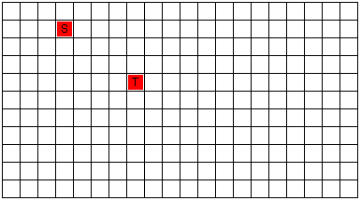
Fig 3. Ready to route – S: Source, T: Destination

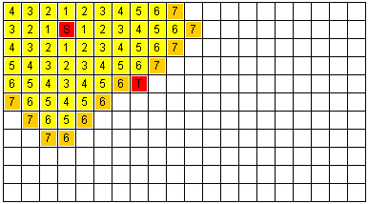
Fig 4. Expansion phase – Target is found

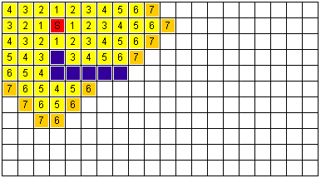
Fig 5. Traceback phase

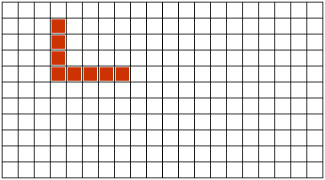
Fig 6. Traceback complete

Figure 7 demonstrates the algorithm trying to find a separate connection on both sides of a blockage. The waves propagate around the blockage to reach the destination node.

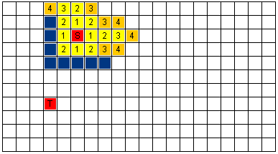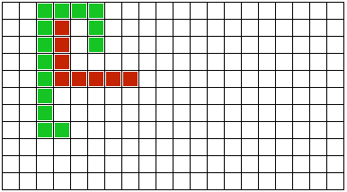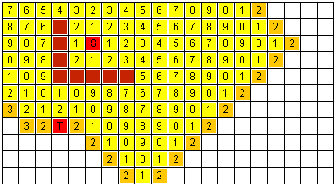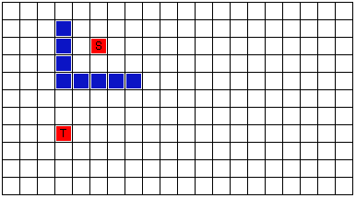
Fig 7. Dealing with blockage

Mapping Lee Algorithm onto Parallel Architectures

Lee Algorithm is simple and easy to implement; however, since it is computationally intensive, it seems to be an attractive candidate for implementation on parallel systems. Mapping the cells onto parallel format is critical to the efficiency of the algorithm. Grid cells can be mapped directly onto a parallel architecture. Different parallelization methods acquire different mapping strategies to improve efficiency of the system. One scheme maps the algorithm to a mesh or hypercube computer and performs wave front expansion in parallel. Some systems use pipelining methods to parallelize subsequent phases of the algorithm. Also letting expansion waves start from both source and destination could contribute in the enhancement of the parallel system. One strategy aims to increase processor utilization by partitioning the grid space into covering rectangles and by mapping each triangle to a processor. In this scheme they keep the size of rectangles as parameters and try to find the optimal parameters to increase processor utilization. In this case when size of covering rectangles decreases, the number of boundary cells and therefore the processor utilization increases.

Parallel Implementation

Lee algorithm can work very well in a SIMD application. In this scheme a wave can be propagated in parallel and each node can propagate many waves. MPI allows parallel processing of many signals which is limited by number of processors. In this case each node can connect one signal. Speedup is the result of having each process route the portion of connections which is obtained by dividing the number of connections by the number of processors. The routing can be done in parallel. Speedup is expected to be proportional to number of processors especially for large ASICs.
Figure 8 and 9 depict the flow charts of the sequential and parallel implementations. As shown in figure 9, the first part of the algorithm is accomplished by processor 0 and the task of finding connections between different terminals are performed by all processors in parallel format to enhance system performance. At the end of the program all processors report to processor 0 to demonstrate the final result.

Sequential Flow chart for Lee Algorithm

Fig 8. Sequential implementation flow chart

Parallelized Flow chart for Lee algorithm

Fig 9. Parallel implementation flow chart

Results and Findings

For the input data 5 different routing files named fcct1, fcct2, fcct3, fcct4 and fcct5 were used. All files are grids with the collection of routing terminals that are simulated to be connected. “fcct1” has a very small grid with only 7 connections. “fcct2, 3, 4, 5” have increasingly larger size and more connections thus require more computation time. “fcct5” which is the largest file has about 4000 connections. This is the file that we expect to observe the best result after system parallelization.
The first set of experiment was done with the following setup:
- MPI for Windows
- 3 Machines
- DragoAMD – AMD Phenom II x4, 3.2 GHz - Ethernet
- Dina-netbook – AMD Athlon,1.2 GHz – Wi-Fi
- HTPC – AMD k8 x2, 2.1 GHz – Wi-Fi
Process 0 was used to measure time. HTPC turned out to be the slowest while DragoAMD was the fastest. Two different setups were used to collect results:
Trial 1: Dina-netbook is process 0
Trial 2: HTPC is process 0
Trial 1 had a bug and all processes ran one after another. Therefore execution time increased as more processes were added. In this case the results were especially bad because process 2 was HTPC which was the slowest processor. Trial 2 had HTPC as the first process so by adding processes, we improved performance. Figure 10 demonstrates the sample program output where all processes print their machine name to screen. This is how we know all machines are running. Process 0 prints timing data to the log file
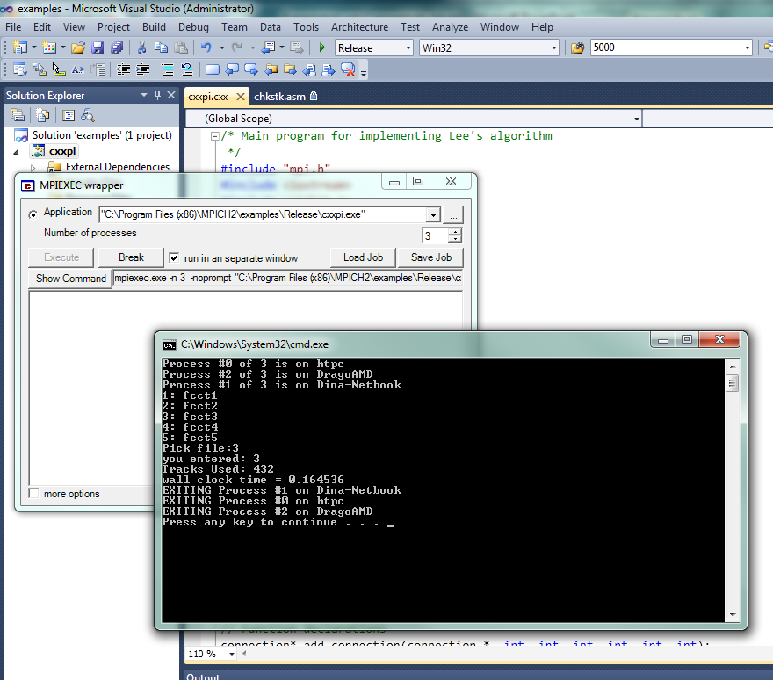

Fig 10. Sample output

Real program output demonstrates the routing results which were not printed with parallel program since it is difficult to recompile with the graphics package. Figure 11 shows the sequential program outputs grid. In this figure each routing track is recognized with different color.

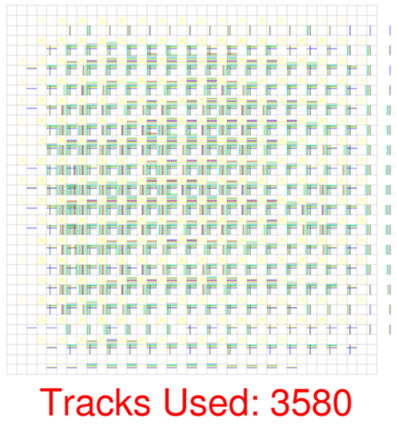
Fig 11. Sequential program outputs grid

Figures 12 to 15 demonstrate the result when experiment was done with the above mentioned processors and trial specifications.

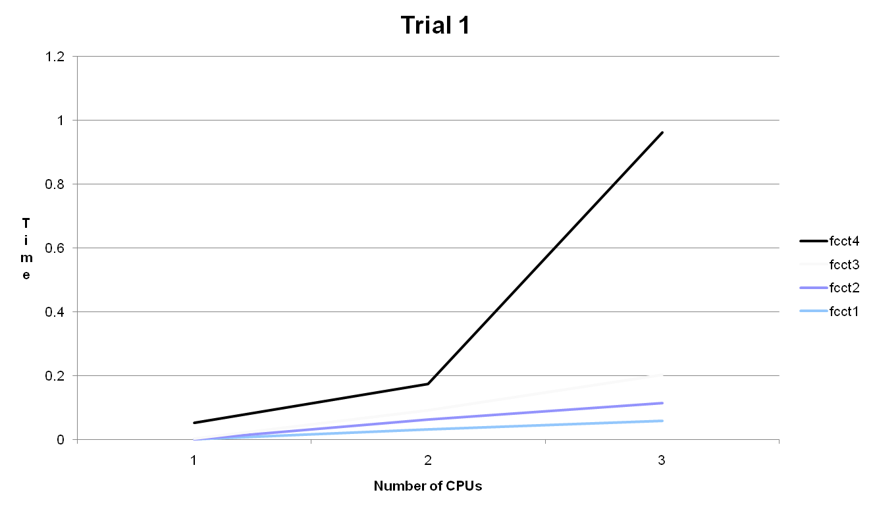
Fig 12. Trial 1 for fcct1, 2, 3, 4

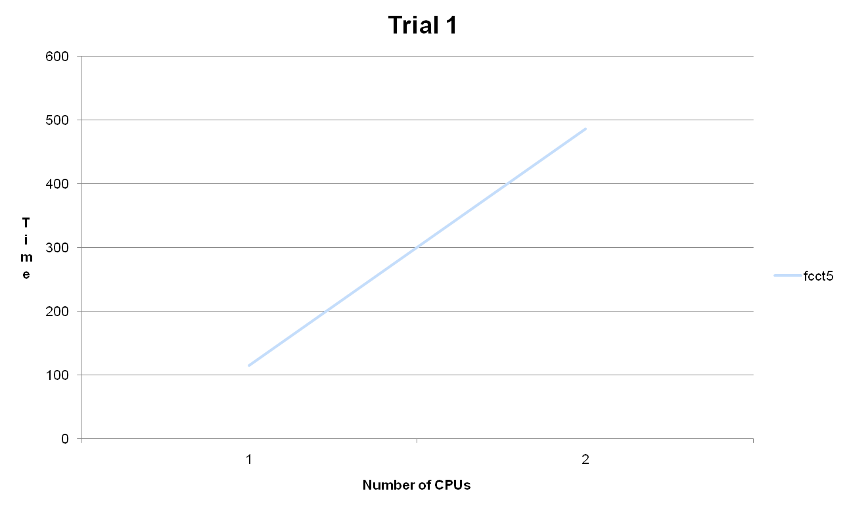
Fig 13. Trial 1 for fcct5

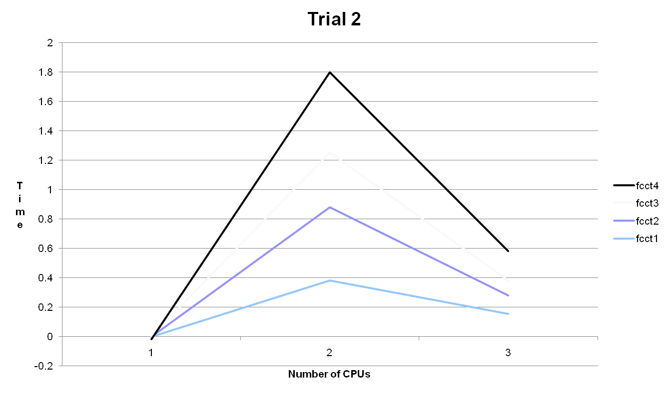
Fig 14. Trial 2 for fcct1, 2, 3, 4

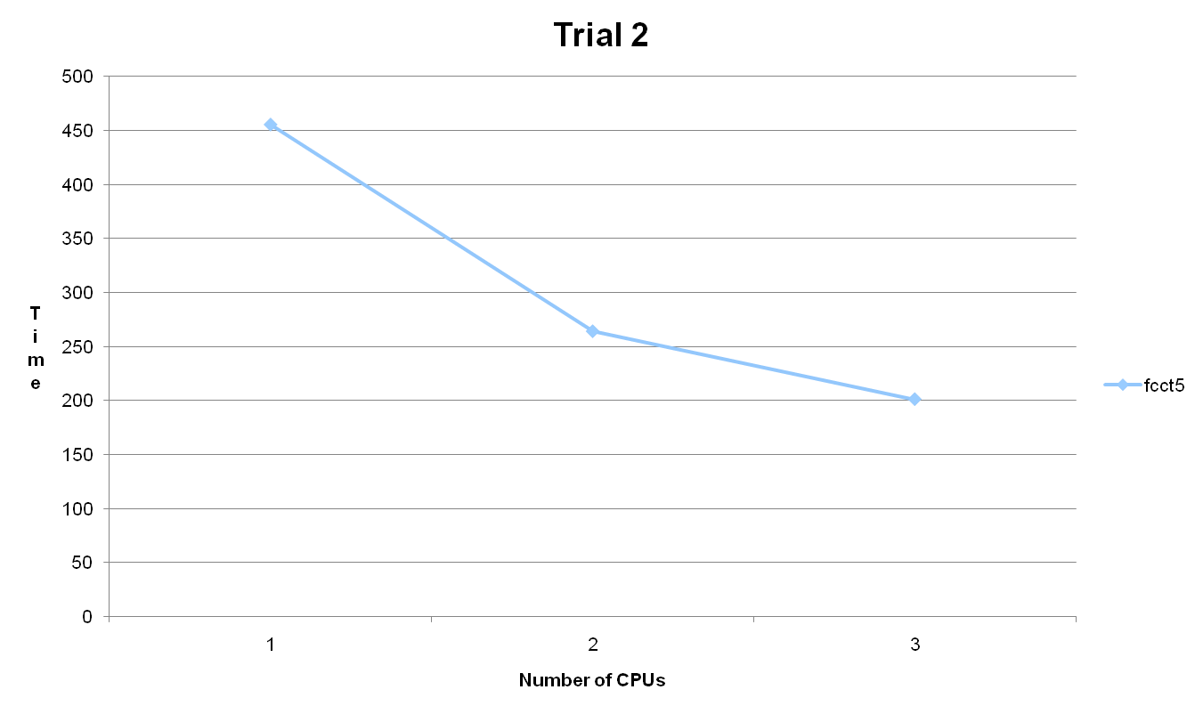
Fig 15. Trial 2 for fcct5

In this set of experiments the MPIBarrier function did not seem to work as expected. This might have been the cause for the unexpected results for fcct1, 2, 3, and 4. It seems that it did not synchronize processes properly. We tested the matter by putting a print statement immediately after the Barrier call. The print to screen did not come at the same (or even similar) time from all CPUs. For this set of experiment where not all CPUs have the same performance, there can be significant gains from carefully splitting the workload. One option is to dynamically assign tasks to the process with least workload. In this case one process would be wasted on dispatching tasks.
We parallelized the Lee algorithm, not the chip routing algorithm. The Lee algorithm is just one step in chip routing. To successfully route the entire chip, there needs to be communication between processes, since they’re all using joint routing resources

Final Results

For the second set of experimentations we used 19 processors gradually to measure performance. Figure 16 and 17 demonstrate the result when experiments were done in Ryerson lab with 19 Linux machines. We expected to see best result in the larger files specifically in file “fcct5” with around 4000 connections. By adding processes, we improved performance in these files as expected. As shown in figure adding the sixth processor to the largest file saturated the system. Five processors turned out to be the optimal number for the file of this size.

Fig 16. Final results for fcct4 with 5 processors

Fig 17. Final results for the largest file “fcct5” with 13 processors

Conclusion

We were able to achieve optimal efficiency of the Lee algorithm by parallelizing the wave expansion phase. Implementing this on up to thirteen processors reduced the processing time drastically. The parallel implementation was more efficient with larger circuits, with a large number of tracks, indicating that the more complex the circuit, the more efficient output result obtained.

References

[1] I-Ling Yen, Rumi M Dubash, Farokh B. Bastani, “Stategies for Mapping Lee’s Maze Routing Algorithm onto Parallel Architectures”
[2] Jianjiang Ceng, Stefan Kraemer, “Maze Router with Lee Algorithm”, Rwthaachen Univarsity
[3]http://www.eecs.northwestern.edu/~haizhou/357/lec6.pdf
[4] http://www.princeton.edu/~wolf/modern-vlsi/Overheads/CHAP10-1/sld025.htm
[5] http://cadapplets.lafayette.edu/MazeRouter.html
[6] http://en.wikipedia.org/wiki/Lee_algorithm
[7] Wikipedia

Appendix
Source Code of
Parallel Implementation of Lee Algorithm

/* Main program for implementing Lee's algorithm
*/
#include "mpi.h"
#include <iostream>
#include <stdlib.h>
//#include <direct.h>
#include <math.h>
//#define PRINT_GRIDS
//#define DEBUG_PRINT
#define TEXT_PRINT
//#define PRINT_GRIDS_INITIAL
#define CELL_SIZE 100

void print_grid (int[][100], int);
static void delay (void);
static void button_press (float x, float y);
static void drawscreen (int);
static void new_button_func (void (*drawscreen_ptr) (void));
void my_setcolor(int);
void endMe (int, char*);
// This stuff should really be moved to the .h file
// Structure for hol ding data
typedef struct connection {
int x1, y1, p1, x2, y2, p2;
} connection;

typedef struct grid {
int x, y, value;
} grid;

// Function declarations
connection* add_connection(connection *, int, int, int, int, int, int);
void print_connection(connection*, int, int, int, int, int, int);

using namespace std;

double f(double);

double f(double a)
{
return (4.0 / (1.0 + a*a));
}
//void GetCurrentPath(char* buffer)
//{
//getcwd(buffer, _MAX_PATH);
//}

int main(int argc,char **argv)
{
int n, myid, numprocs, i ;
double PI25DT = 3.141592653589793238462643;
double mypi, pi, h, sum, x;
double startwtime = 0.0, endwtime;
int namelen;
char processor_name[MPI_MAX_PROCESSOR_NAME];
/* */
FILE *fp;
FILE *logfile;
char line[14];
char *p;
int r=5; // Rows and columns (grid)
int w=55; // Routing tracks in each channel

int x1, y1, p1, x2, y2, p2;
int point_count;
int found;
int level;
int prevJ;
int prevK;

int startX;
int startY;
int endX;
int endY;
char filename[40];
char my_string[40];
int k, j, z;
int line_count=0;
int conn;
int grid_size=6;
int grid[100][100];
int grid_tracks[100][100];
int tracks_used = 0;
int total_tracks_used;
int starting_grid[100][100];

// Initialize MPI
MPI::Init(argc,argv);
numprocs = MPI::COMM_WORLD.Get_size();
myid = MPI::COMM_WORLD.Get_rank();
MPI::Get_processor_name(processor_name,namelen);

cout << "Process #" << myid << " of " << numprocs << " is on " << processor_name << endl;

// Create variable to hold all connections
connection my_connections[10000];

#ifdef DEBUG_PRINT
char CurrentPath[50];
//GetCurrentPath(CurrentPath);
cout << CurrentPath << endl;
#endif

MPI::COMM_WORLD.Barrier();
//Get connectivity information from file. Only Host process needs to do this
if (myid == 0){
fprintf(stdout, "1: fcct1\n2: fcct2\n3: fcct3\n4: fcct4\n5: fcct5\nPick file:");
fflush(stdout);
if (scanf("%d",&n) != 1) {
fprintf( stdout, "No number entered; quitting\n" );
endMe(myid, processor_name);
}
else {
fprintf( stdout, "you entered: %d \n", n );
switch(n){
case 1:
sprintf(filename, "%s", "fcct1");
break;
case 2:
sprintf(filename, "%s", "fcct2");
break;
case 3:
sprintf(filename, "%s", "fcct3");
break;
case 4:
sprintf(filename, "%s", "fcct4");
break;
case 5:
sprintf(filename, "%s", "fcct5");
break;
default: sprintf(filename, "%s", "fcct1");
}
}

#ifdef DEBUG_PRINT
printf("Filename: %s\n", filename);
#endif

fp = fopen (filename, "r"); // Open file
if(myid == 0)
logfile = fopen ("mylogfile.log", "a+"); // Open file
if(fp==NULL){
cout << "ERROR: Cant open file. Process " << myid << " of " << numprocs << " on " << processor_name << endl;
}
line_count = 0;
while(!feof(fp)){
if (line_count ==0) {
fscanf(fp, "%d", &r);
}
else if (line_count ==1) {
fscanf(fp, "%d", &w);
}
else {
fscanf(fp, "%d %d %d %d %d %d\n", &x1, &y1, &p1, &x2, &y2, &p2);
//printf("%d,%d,%d,%d,%d,%d\n", x1, y1, p1, x2, y2, p2);
if(x1==-1|y1==-1|x2==-1|y2==-1)
break;
else{
add_connection(my_connections + line_count-2, x1, y1, p1, x2, y2, p2);
}
}
line_count++;
}
fclose(fp);
startwtime = MPI::Wtime(); // Get Starting time
} // End Process 0 portion
MPI::COMM_WORLD.Bcast(&line_count, 1, MPI_INT, 0);
MPI::COMM_WORLD.Bcast(&r, 1, MPI_INT, 0);
MPI::COMM_WORLD.Bcast(&w, 1, MPI_INT, 0);
MPI::COMM_WORLD.Bcast(&my_connections, 10000, MPI_INT, 0); // if it doesn't work change to 10000
MPI::COMM_WORLD.Barrier(); // Synchronize all processes
#ifdef DEBUG_PRINT
printf("R: %d\nW: %d\nline_count: %d\n", r, w, line_count);
#endif
point_count = line_count-2;
// Create grid - it will have (r+2)*2-1 rows and colums
// This number comes from the fact that there are 2 extra rows/colums for IOs,
// and we'll need to label both BLEs and routing resources on the grid

grid_size = (r+2)*2-1;
#ifdef DEBUG_PRINT
printf("Process %d found Grid size %d, r: %d\n", myid, grid_size, r);
#endif

// Fill the grid:
// 99 -> blocked off
// 98 -> BLE
// 97 -> Switchbox - assume routable
// 96 -> Routing track
// w -> Routing track - the value will tell us how many tracks are available
for(k=0; k<(r+2)*2-1; k++){
for(j=0; j<(r+2)*2-1; j++){
if(k==0 || k==grid_size-1){
if(j%2==0){
grid[j][k] = 98;
grid_tracks[j][k] = 98;
}
else {
grid[j][k] = 99;
grid_tracks[j][k] = 99;
}
}
else if(k%2==0){
if(j%2==0){
grid[j][k] = 98;
grid_tracks[j][k] = 98;
}
else{
grid[j][k] = 96;
grid_tracks[j][k] = w;
}
}
else{
if(j==0 || j==grid_size-1) {
grid[j][k] = 99;
grid_tracks[j][k] = 99;
}
else if(j%2==0){
grid[j][k] = 96;
grid_tracks[j][k] = w;
}
else{
grid[j][k] = 97;
grid_tracks[j][k] = 97;
}
}
}
}

// Block off corners
grid[0][0] = 99;
grid[0][grid_size-1] = 99;
grid[grid_size-1][0] = 99;
grid[grid_size-1][grid_size-1] = 99;
grid[grid_size-1][grid_size-1] = 99;

// Print out grid to make sure we're ok
#ifdef PRINT_GRIDS_INITIAL
for(k=(r+2)*2-2; k>=0; k--){
printf("+++++++++++++++++++++++++++++++++++++++++++++++++++++++++++++++++++++++++++++\n");
for(j=0; j<(r+2)*2-1; j++){
printf("| %2d ", grid[j][k]);
}
printf("|\n");
}
printf("+++++++++++++++++++++++++++++++++++++++++++++++++++++++++++++++++++++++++++++\n");
for(k=(r+2)*2-2; k>=0; k--){
printf("============================================================================\n");
for(j=0; j<(r+2)*2-1; j++){
printf("| %2d ", grid_tracks[j][k]);
}
printf("|\n");
}
printf("============================================================================\n");
#endif
//Copy Grids -starting_grid is non-routed
for(k=(r+2)*2-2; k>=0; k--){
for(j=0; j<(r+2)*2-1; j++){
starting_grid[j][k] = grid[j][k];
}
}
//} // End Process 0 portion

// Send grid to all processes
//MPI::COMM_WORLD.Bcast(&grid, 10000, MPI_INT, 0);
//MPI::COMM_WORLD.Bcast(&grid_tracks, 10000, MPI_INT, 0);
//MPI::COMM_WORLD.Bcast(&my_connections, 10000, MPI_INT, 0);
//MPI::COMM_WORLD.Bcast(&starting_grid, 10000, MPI_INT, 0);
//MPI::COMM_WORLD.Bcast(&point_count, 1, MPI_INT, 0);
//MPI::COMM_WORLD.Bcast(&r, 1, MPI_INT, 0);

// MAIN FOR LOOP
for(conn=0; conn<point_count; conn++){
if(conn%numprocs == myid){
#ifdef DEBUG_PRINT
cout << "Conn: " << conn << " of " << point_count << " on " << myid << endl;
#endif
//grid = starting_grid;
for(k=(r+2)*2-2; k>=0; k--){
for(j=0; j<(r+2)*2-1; j++){
grid[j][k] = starting_grid[j][k];
}
}
connection *s = my_connections+conn;
// Convert coordinates to new grid
s->x1 = s->x1*2;
s->x2 = s->x2*2;
s->y1 = s->y1*2;
s->y2 = s->y2*2;

// Check that start and enpoints are correct
if((grid[s->x1][s->y1] != 98) || (grid[s->x2][s->y2] != 98)){
printf("Startpoint: X: %d Y: %d\n",grid[s->x1][s->y1]);
printf("Endpoint: X: %d Y: %d\n",grid[s->x2][s->y2]);
printf("Error, incorrect start or endpoint\n");
}
// Get start pin
// Check if it's an IO port
if(s->x1==0){
startX = s->x1 + 1;
startY = s->y1;
}
else if(s->y1==0){
startX = s->x1;
startY = s->y1 + 1;
}
else if(s->x1==grid_size-1){
startX = s->x1 - 1;
startY = s->y1;
}
else if(s->y1==grid_size-1){
startX = s->x1;
startY = s->y1 - 1;
}
else { // Move connection based on which pin we're connecting
if(s->p1==0){
startX = s->x1;
startY = s->y1 + 1;
}
else if(s->p1==1){
startX = s->x1 - 1;
startY = s->y1;
}
else if(s->p1==2){
startX = s->x1;
startY = s->y1 - 1;
}
else if(s->p1==3){
startX = s->x1 + 1;
startY = s->y1;
}
else if(s->p1==4){
startX = s->x1 + 1;
startY = s->y1;
}
}
// Get end pin
// Check if it's an IO port
if(s->x2==0){
endX = s->x2 + 1;
endY = s->y2;
}
else if(s->y2==0){
endX = s->x2;
endY = s->y2 + 1;
}
else if(s->x2==grid_size-1){
endX = s->x2 - 1;
endY = s->y2;
}
else if(s->y2==grid_size-1){
endX = s->x2;
endY = s->y2 - 1;
}
else { // Move connection based on which pin we're connecting
if(s->p2==0){
endX = s->x2;
endY = s->y2 + 1;
}
else if(s->p2==1){
endX = s->x2 - 1;
endY = s->y2;
}
else if(s->p2==2){
endX = s->x2;
endY = s->y2 - 1;
}
else if(s->p2==3){
endX = s->x2 + 1;
endY = s->y2;
}
else if(s->p2==1){
endX = s->x2 + 1;
endY = s->y2;
}
}
if(grid_tracks[startX][startY] > 0){
//grid_tracks[startX][startY]--;
//printf("Routable %d\n", grid_tracks[startX][startY]);
}
else {
// Can't route
printf("Can't route this signal - all tracks used up %d\n", grid_tracks[startX][startY]);
break;
}
//printf("CONN %d :: Connecting loc %d, %d to loc %d, %d\n", conn, startX, startY, endX, endY);

grid[startX][startY] = 0; // Starting point
level=0;
found = 0;
while (found==0) {
for(k=0; k<(r+2)*2-1; k++){
for(j=0; j<(r+2)*2-1; j++){
//if(myid==1)
//printf("j %d, k %d\n", j, k);
if(grid[j][k]==level){
if(grid[j+1][k]==97){
grid[j+1][k]=level+1;
}
else if(grid[j+1][k]==96){
if(grid_tracks[j+1][k]>0){
grid[j+1][k]=level+1;
}
}
if(grid[j][k+1]==97){
grid[j][k+1]=level+1;
}
else if(grid[j][k+1]==96){
if(grid_tracks[j][k+1]>0){
grid[j][k+1]=level+1;
}
}
if(grid[j-1][k]==97){
grid[j-1][k]=level+1;
}
else if(grid[j-1][k]==96){
if(grid_tracks[j-1][k]>0){
grid[j-1][k]=level+1;
}
}
if(grid[j][k-1]==97){
grid[j][k-1]=level+1;
}
else if(grid[j][k-1]==96){
if(grid_tracks[j][k-1]>0){
grid[j][k-1]=level+1;
}
}
}
}
}
level++;
if(grid[endX][endY]!=96)
found = 1;
}
// Back-track trough connection
found = 0;
j=endX;
k=endY;
level = grid[endX][endY];
grid[endX][endY] = grid[endX][endY]+100;
grid_tracks[endX][endY]--;
tracks_used++;
while(found==0){
if(level==1){
found=1;
}
if(grid[j-1][k]==level-1){
j=j-1;
}
else if(grid[j][k-1]==level-1){
k=k-1;
}
else if(grid[j+1][k]==level-1){
j=j+1;
}
else if(grid[j][k+1]==level-1){
k=k+1;
}
grid[j][k] = grid[j][k]+100;
if(grid_tracks[j][k]!=97){
grid_tracks[j][k]--;
tracks_used++;
}
level--;
}
// Print out grid to make sure we're ok
#ifdef PRINT_GRIDS
for(k=(r+2)*2-2; k>=0; k--){
#ifdef TEXT_PRINT
for(z=0; z<=(r+2)*2-2; z++){
printf("-----");
}
printf("\n");
#endif
for(j=0; j<(r+2)*2-1; j++)
{
if(grid[j][k]>=100){
#ifdef TEXT_PRINT
printf("|*%2d ", grid[j][k]-100);
#endif
sprintf(my_string, "%2d", grid[j][k]-100);
#ifdef SHOW_TRACKS
setcolor(YELLOW);
if(k%2==0){
my_setcolor (grid_tracks[j][k]%8);
fillrect (10+(float)j*CELL_SIZE + 10*(grid_tracks[j][k]),10+(float)k*CELL_SIZE,10+(float)(j)*CELL_SIZE + 10*(grid_tracks[j][k])+4,10+(float)(k+1)*CELL_SIZE);
}
else if(j%2==0){
my_setcolor (grid_tracks[j][k]%8);
fillrect (10+(float)j*CELL_SIZE,10+(float)k*CELL_SIZE + 10*(grid_tracks[j][k]),10+(float)(j+1)*CELL_SIZE,10+(float)(k)*CELL_SIZE + 10*(grid_tracks[j][k])+4);
}
else {
// Switchbox
setlinestyle (DASHED);
drawline (10+(float)(j+1)*CELL_SIZE,10+(float)(k)*CELL_SIZE,10+(float)(j)*CELL_SIZE,10+(float)(k)*CELL_SIZE + CELL_SIZE);
drawline (10+(float)j*CELL_SIZE,10+(float)k*CELL_SIZE,10+(float)(j)*CELL_SIZE + CELL_SIZE,10+(float)(k+1)*CELL_SIZE);
setlinestyle (SOLID);
}
setcolor (BLACK);
#endif
#ifdef SHOW_PATHS
my_setcolor (conn%8);
if(k%2==0){
drawline (10+(float)(j)*CELL_SIZE+10*conn+10,10+(float)(k)*CELL_SIZE,10+(float)(j)*CELL_SIZE+10*conn+10,10+(float)(k+1)*CELL_SIZE);
prevJ = j; // vertical line
prevK = k;
}
else if(j%2==0){
drawline (10+(float)(j)*CELL_SIZE,10+(float)(k)*CELL_SIZE+10*conn+10,10+(float)(j+1)*CELL_SIZE,10+(float)(k)*CELL_SIZE+10*conn+10);
prevJ = j; // horizontal line
prevK = k;
}
else {
// Switchbox
printf("\nPrevJ %d PrevK %d\nj: %d, k: %d\n", prevJ, prevK, j, k);
if(prevJ>j){ // previous block above
drawline (10+(float)(j)*CELL_SIZE,10+(float)(k)*CELL_SIZE+10*conn+10,10+(float)(j+1)*CELL_SIZE,10+(float)(k)*CELL_SIZE+10*conn+10);
}
else if(prevJ<j){ // previous block below
drawline (10+(float)(j)*CELL_SIZE,10+(float)(k)*CELL_SIZE+10*conn+10,10+(float)(j)*CELL_SIZE+10*conn+10,10+(float)(k)*CELL_SIZE+10*conn+10);
drawline (10+(float)(j)*CELL_SIZE+10*conn+10,10+(float)(k)*CELL_SIZE,10+(float)(j)*CELL_SIZE+10*conn+10,10+(float)(k)*CELL_SIZE+10*conn+10);
}
else if(prevK<k){ // previous block to the left
drawline (10+(float)(j)*CELL_SIZE,10+(float)(k)*CELL_SIZE+10*conn+10,10+(float)(j+1)*CELL_SIZE,10+(float)(k)*CELL_SIZE+10*conn+10);
}
else if(prevK>k){ // previous block to the right
drawline (10+(float)(j)*CELL_SIZE+10*conn+10,10+(float)(k)*CELL_SIZE,10+(float)(j)*CELL_SIZE+10*conn+10,10+(float)(k+1)*CELL_SIZE);
}
}
#endif
//drawtext (10+(float)j*CELL_SIZE+CELL_SIZE/2,10+(float)k*CELL_SIZE+CELL_SIZE/2,my_string,500.);
}
else{
#ifdef TEXT_PRINT
printf("| %2d ", grid[j][k]);
#endif
}
}
#ifdef TEXT_PRINT
printf("|\n");
#endif
}
#ifdef TEXT_PRINT
for(z=0; z<=(r+2)*2-2; z++){
printf("-----");
}
printf("\n");
#endif
// Tracks
#ifdef TEXT_PRINT
for(k=(r+2)*2-2; k>=0; k--){
for(z=0; z<=(r+2)*2-2; z++){
printf("+++++");
}
printf("\n");
for(j=0; j<(r+2)*2-1; j++)
{
if(grid_tracks[j][k]>=100){
printf("|*%2d ", grid_tracks[j][k]-100);
}
else{
printf("| %2d ", grid_tracks[j][k]);
}
}
printf("|\n");
}
for(z=0; z<=(r+2)*2-2; z++){
printf("+++++");
}
printf("\n");
#endif
#endif
}
}

MPI::COMM_WORLD.Reduce(&tracks_used, &total_tracks_used, 1, MPI_INT, MPI_SUM, 0);
if (myid == 0)
printf("Tracks Used: %d\n", total_tracks_used);

n = 10000; /* default # of rectangles */

MPI::COMM_WORLD.Bcast(&n, 1, MPI_INT, 0);

h = 1.0 / (double) n;
sum = 0.0;

MPI::COMM_WORLD.Reduce(&mypi, &pi, 1, MPI_DOUBLE, MPI_SUM, 0);

if (myid == 0) {
// Get Runtime and put it in the logfile
endwtime = MPI::Wtime();
cout << "wall clock time = " << endwtime-startwtime << endl;
fprintf(logfile, "File: %s\tTime: %.8f\tNum Procs: %d\n", filename, endwtime-startwtime, numprocs);
fclose(logfile);
}

endMe(myid, processor_name);
// delete []grid;
return 0;
} // main

void endMe (int myid, char* processor_name){
MPI::COMM_WORLD.Barrier();
cout << "EXITING Process #" << myid << " on " << processor_name << endl;
MPI::Finalize();
}
connection* add_connection(connection *s, int x1, int y1, int p1, int x2, int y2, int p2)
{
s->x1 = x1;
s->y1 = y1;
s->p1 = p1;
s->x2 = x2;
s->y2 = y2;
s->p2 = p2;
return s;
}

void print_connection(connection *s, int x1, int y1, int p1, int x2, int y2, int p2)
{
printf("X1: %d\n", s->x1);
printf("Y1: %d\n", s->y1);
printf("P1: %d\n", s->p1);
printf("X2: %d\n", s->x2);
printf("Y2: %d\n", s->y2);
printf("P2: %d\n", s->p2);
}

void print_grid (int grid[][100], int r){
int k, j;
for(k=0; k<(r+2)*2-1; k++)
{
for(j=0; j<(r+2)*2-1; j++)
{
printf("loc %d, %d, %d\n", j, k, grid[j][k]);
}
}
}

