OpenMP in Microsoft Windows

Contents
- Introduction ............................................................... 3
- Configuring Microsoft Visual Studio for OpenMP........ 4

1.Introduction
After reading and understanding this manual you will be able to get started with writing OpenMP applications in Microsoft Visual Studio. OpenMP is available for Microsoft Visual Studio. However, OpenMP is not available for the Express or Standard versions of Visual Studio. Therefore, you will need the professional version or higher if you want to use visual studio to develop OpenMP project. It is already included in the package, hence there is no need for installation, just configuration is needed.
For this tutorial, I will be using Visual Studio 2005 professional edition, however, this tutorial will apply to almost all recent versions of Visual Studio.

2. Configuring Microsoft Visual Studio for OpenMP
Open MS Visual Studio and create a new project (Win32 Console Application)
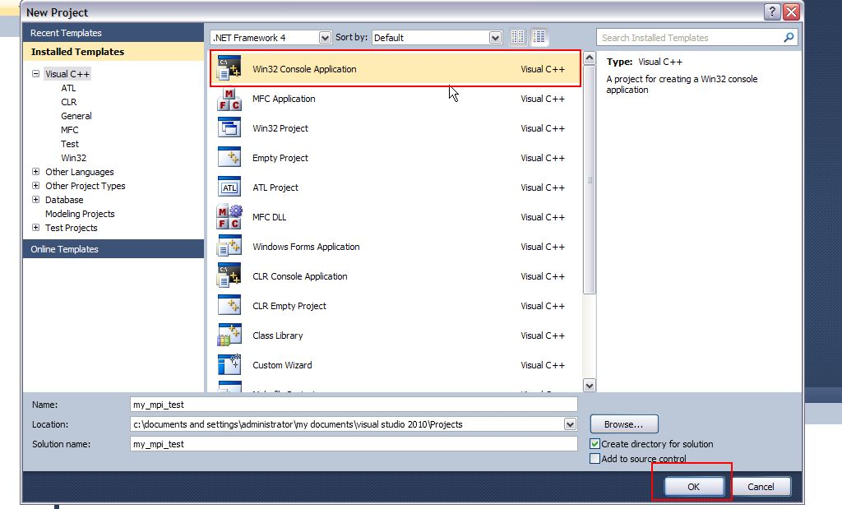
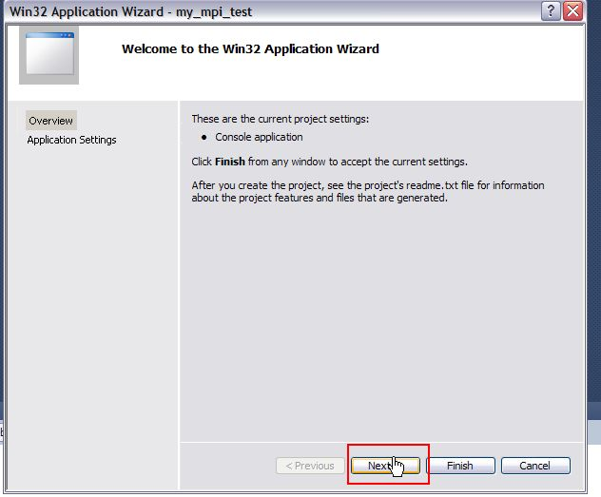
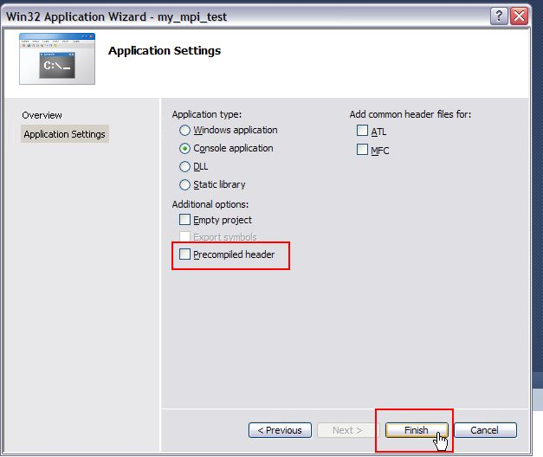
Enable OpenMP
OpenMP does a lot of things automatically for programmers. However, that means that it’s very complicated for the compiler to handle OpenMP. We’ll need to manually enable OpenMP. Right-click on your project in Solution Explorer, and select properties. Select C/C++ -> Language, and change OpenMP Support to Yes. Click ok, and make sure your application still compiles and runs.
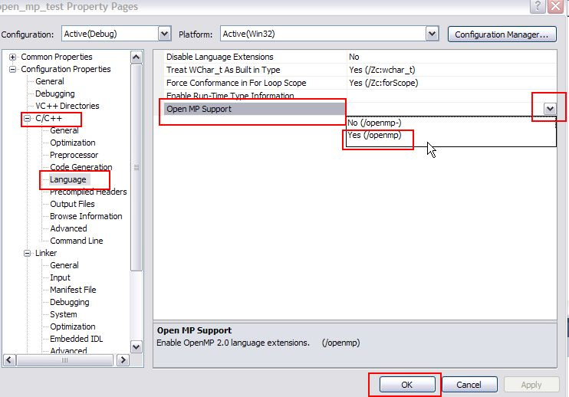

Include openmp.h
While you may not need it right away, it’s a good idea to go ahead and include omp.h in your source code. Visual Studio will already know the location, so all you have to do is type “#include <omp.h>” at the top of your source code.

Try out your program and see if it runs on multiple threads
- Copy the following code in your project
#include "stdafx.h"
#include <omp.h>
#include <iostream>

/*
The purpose of this code is to ensure that OpenMP is working and running on multiple threads.
*/
using namespace std;

int main(int argc, char* argv[])
{
// This statement should only print once
printf("Starting Program!\n");

#pragma omp parallel
{
// This statement will run on each thread.
// If there are 4 threads, this will execute 4 times in total
printf("Running on multiple threads\n");
}

// We're out of the parallelized section.
// Therefore, this should execute only once
printf("Finished!\n");

cin.get();
return 0;
}
- Build & Run it. It should print at the console Running on multiple threads once for each thread.
The program should print, Running on multiple threads, once for each thread. Therefore, if you only see your program print this statement once, that means your program is only running on one thread. By default, Visual studio should detect the total number of processors available in your computer, and start your program with said number of threads. However, if you have a single-core computer, only one thread will be created for your program.
To change this behavior, right-click on your project in the Solution Explorer window, and select properties. In the left-hand column, select “Debugging”. There is a field called “Environment”, which is where we can set environment variables. Try adding this into the environment variables: “OMP_NUM_THREADS=4″, and see if your program now spawns with four threads.
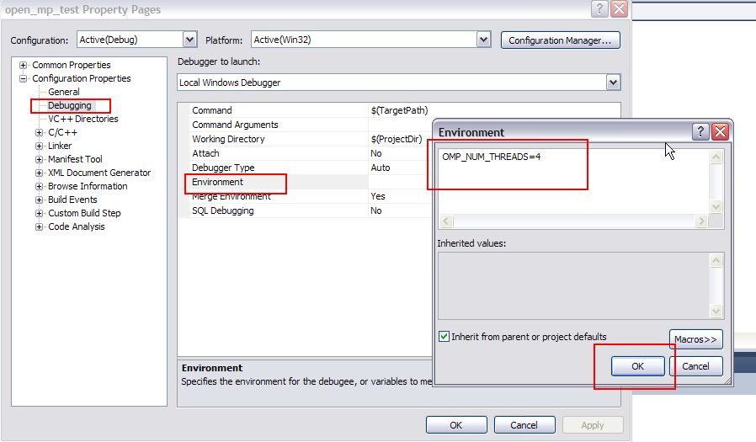

Build & Run it.

