MPI in Microsoft Windows
Installing, compiling and running MPI code

Contents
- Introduction ......................................................................................... 3
- Installing an implementation of the MPI standard .............................. 4
- Configure your development environment for the MPI standard ........7
- Running your MPI application ..............................................................12
4.1 Run a MPI application on a single PC .............................................. .12
4.2 Run a MPI application on a group of Windows PC`s ................15

1.Introduction
This manual describes the steps required to follow in order to install, configure, compile and run MPI on a Microsoft Windows operating system.
Briefly, you have to install an implementation of the MPI standard on your computer, configure your development environment in order to have MPI compatibility, and then learn how to compile and run parallel applications.

2.Installing an implementation of the MPI standard
- Firstly, you have to know on how many bits your processor is running.
- Open Start -> Run and type in winsmd.exe, a system information window will pop up.
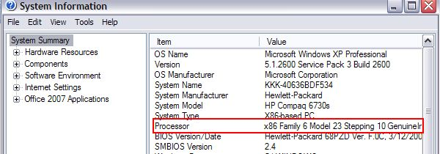
- A x86 model means you have a 32 bit CPU. x64 -> 64 bit CPU
- MPICH2 is an open source MPI implementation. To install it follow the following steps:
- go to the address http://www.mcs.anl.gov/research/projects/mpich2/
- Select downloads -> choose the suitable version for your computer and download it
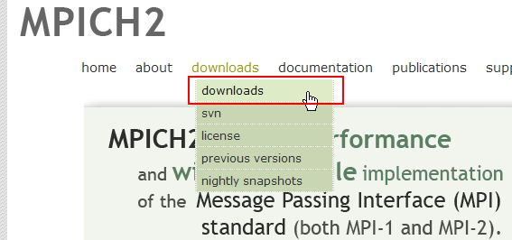
- Select the appropriate version based on you processor (32 or 64 bit processor)
- For 32 bit CPU
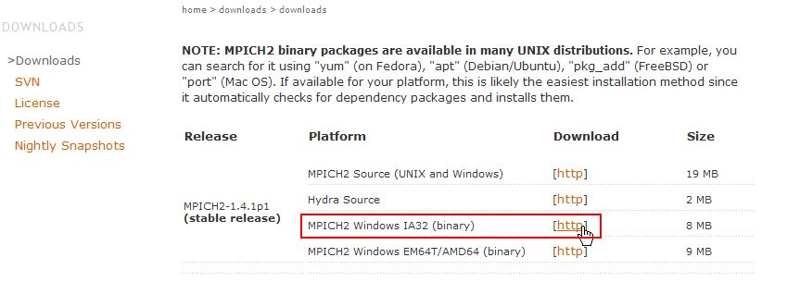

- For 64 bit CPU
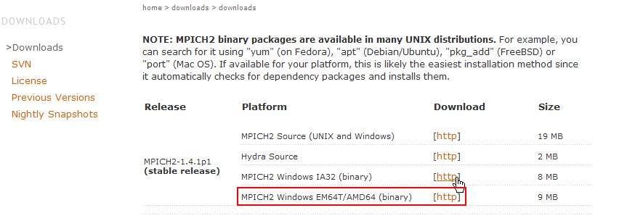
- After you have downloaded the MPICH2 binary, the installation begins, go to the location in which you have saved it and click on ”Run”
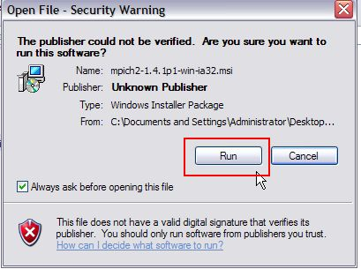

- Although the installation is a next-till-the-end process, be careful with the passphrase section (write it down somewhere to not completely forget it) and with the section in which you choose the destination folder for the install where you will choose a folder at your choice and select the Everyone option regarding the execution rights.
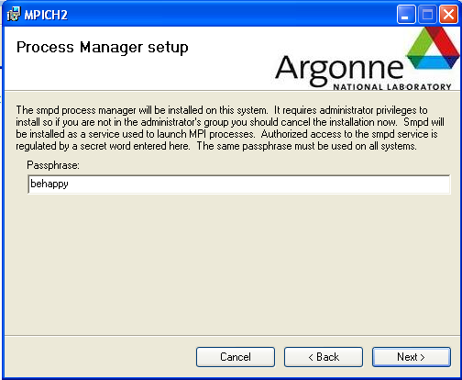
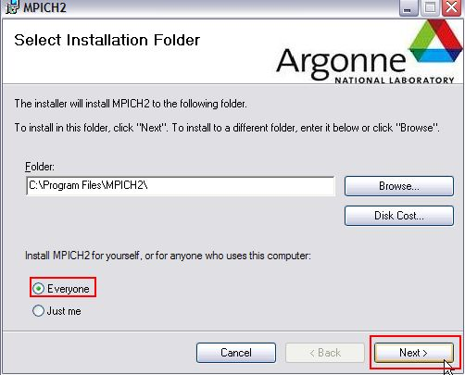

- After the installation is complete, a Windows Security Alert may pop up, click Unblock
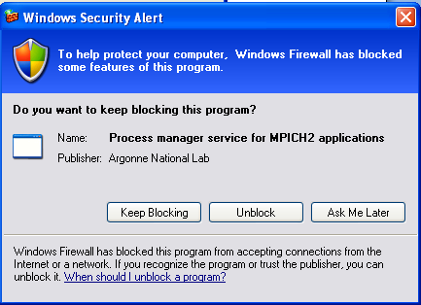
Now you have a MPI implementation installed on your computer and you will use it to run your parallel applications on a single or multiple computers. You can find it in your Start Menu (Start -> Applications -> MPICH2).
If you go to that tab in the Start Menu you will find the following options:
- Jumpshot (visualization program for the logfile format, you will not use it)
- Jumpshot Userguide
- Readme
- wmpiconfig.exe (Configure your MPI running settings)
- wmpiexec.exe (Wrapper for the execution of MPI applications)
- wmpiregister.exe (Set up the account information for your computer)
Now, you`ll set up the account information for your computer, open wmpiregister.exe, on the account field put your username on that computer and on the password field your password and click register then ok.
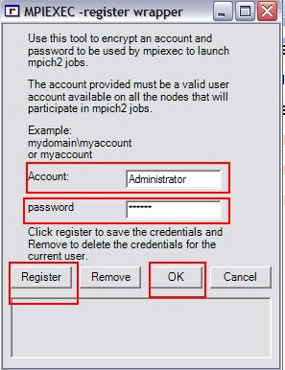

3.Configure your development environment for the MPI standard
The development environment will be Microsoft Visual Studio.
For this, you will need the Microsoft Compute Cluster Pack SDK. You can use the files present in the archive or you can download it from Microsoft, just google Microsoft Compute Cluster Pack SDK and it will be the first link returned or use the link below
http://www.microsoft.com/download/en/details.aspx?id=239
- Click on the above link to install Microsoft Compute Cluster Pack SDK
- Click on any one of the download buttons depending on your computer specification.
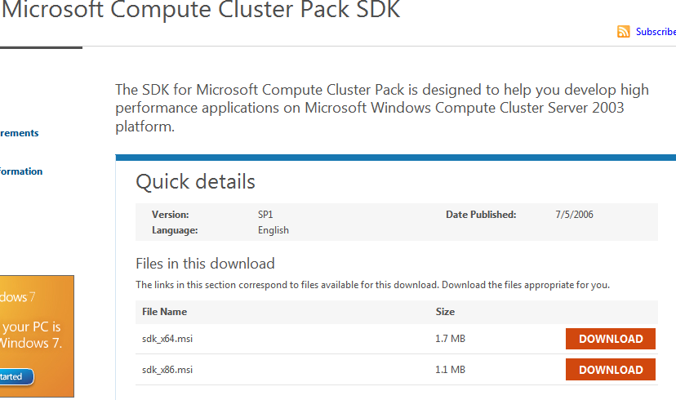
- For 32 bit CPU`s install sdk_x86.msi
- 64 bit CPU`s sdk_x64.msi.
- Click Next all the way to install, just be careful to remember the location in which you`ve installed it.
- Open MS Visual Studio and create a new project (Win32 Console Application)
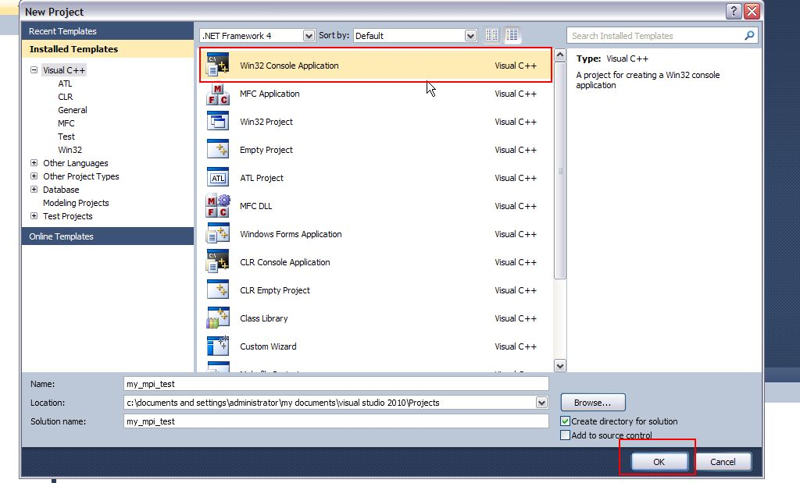
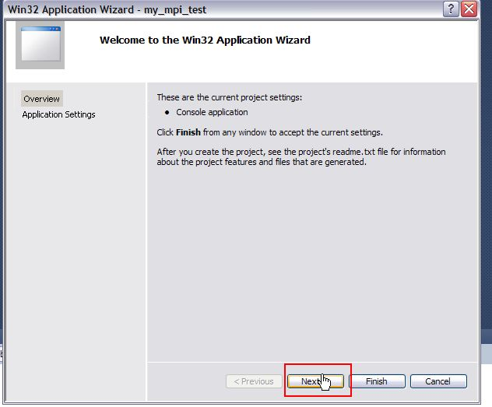
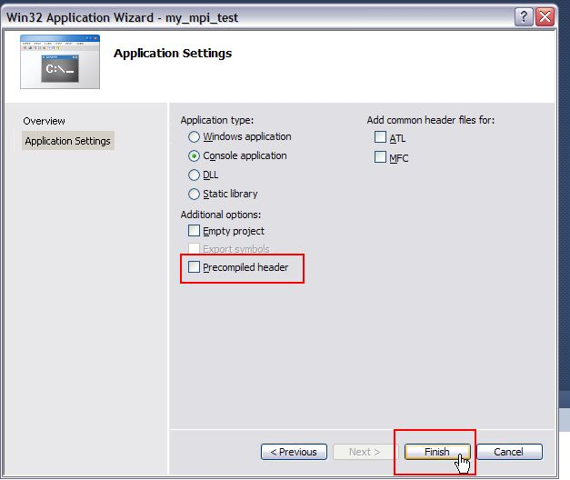
- Next, right-click on your project in the Solution Explorer and select Properties.
- In the pop-up window at Configuration drop-down menu select at All Configurations.
- Select General under the C/C++ menu on the left.
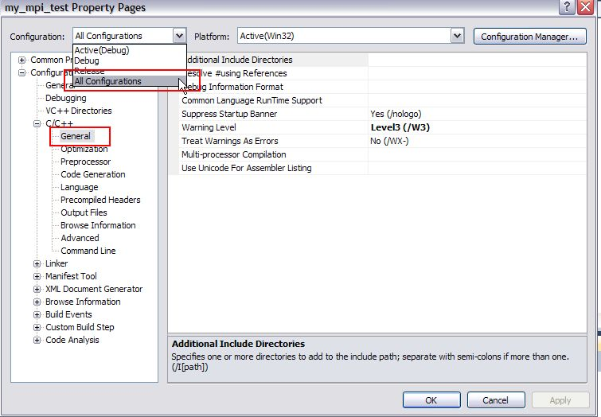

In ”Additional Include Directories” on the right, put the folder in which you installed Microsoft Compute Cluster Pack SDK. In the default case, this is: C:\Program Files\Microsoft Compute Cluster Pack\Include
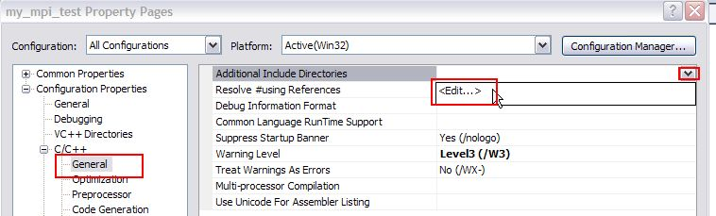
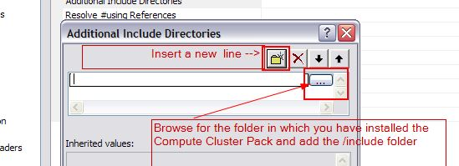
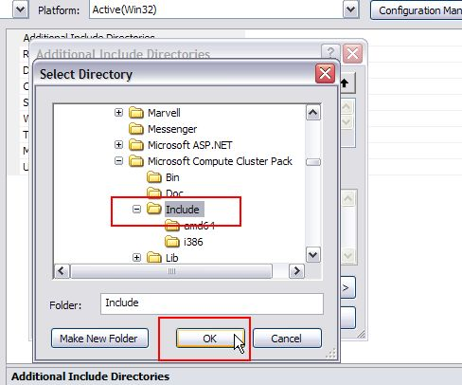

- On the same principle select ”General” under the Linker menu on the left.
- In ”Additional Library Directories” on the right, put the directory in which you installed the Compute Cluster Pack`s lib files.
In the default case, this is: C:\Program Files\Microsoft Compute Cluster Pack\Lib\i386.
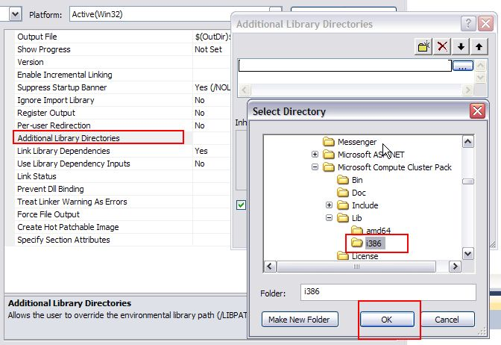
- Select ”Input” under the same Linker menu on the left.
- In ”Additional Dependencies” on the right side, type in msmpi.lib, in order to use the MPI libraries.

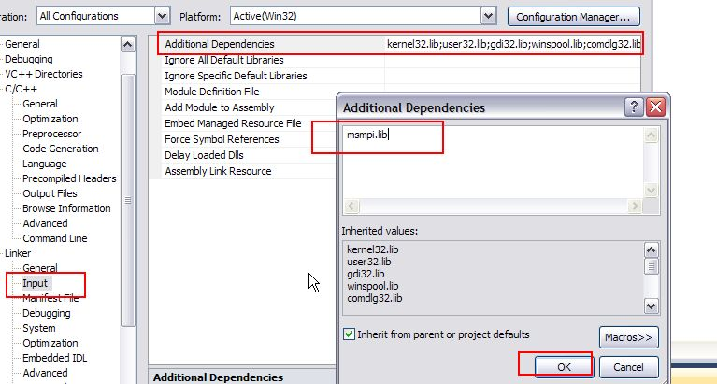
- Select Advanced under the C/C++ menu on the left.
- In ”Compile As” on the right side, select Compile as C Code (/TC) if your program is just C and not C++.
- After this, click Apply and you`re good to go.
- Input your program and compile it by selecting ”Build Solution” from the Build menu at the top of the screen.
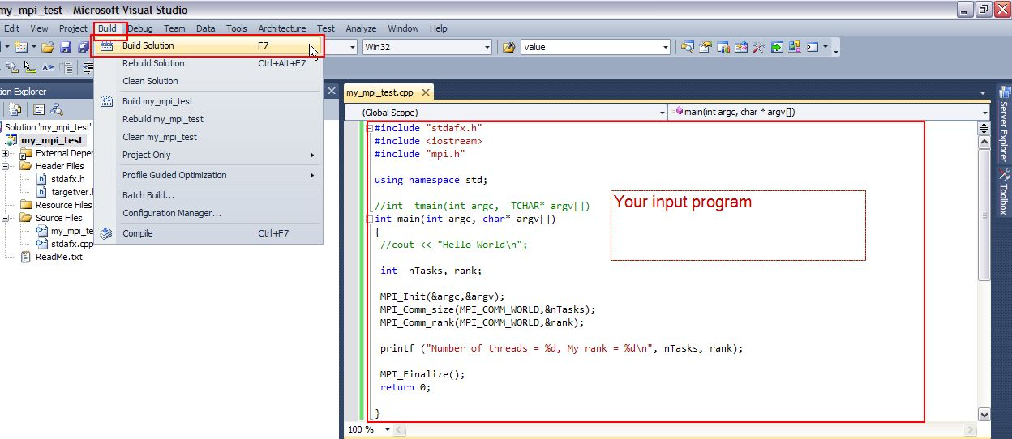

4.Running your MPI application
4.1 Running MPI applications on a single PC
You can simulate multiple processes on a single CPU. If you processor is multi-core the number of cores is the maximum real number of processes you can have.
After you`ve built your input program in MS Visual Studio you now have an exe file located in your project`s folder.
Depending on which settings you have used in the Build step, it should be in the Debug or Release folder.
To navigate to your projects folder right-click on you project`s name in the Solution Explorer and select Open Folder in Windows Explorer.
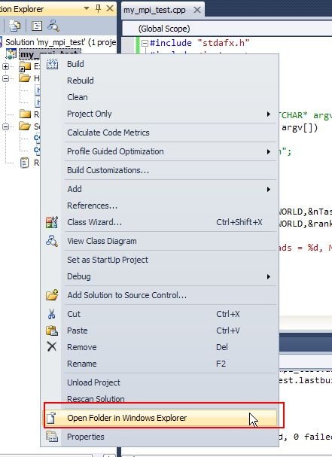
- This will position you in a subfolder of your project, you need to reach the parent folder, so go up one folder.

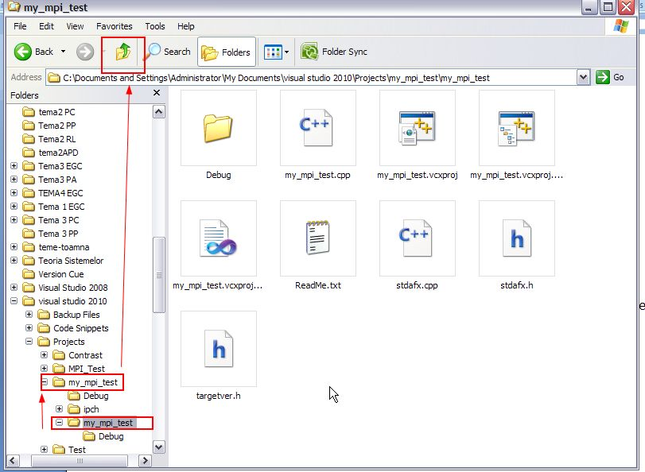
- Once you reach the parent folder of your project, open the Debug or Release folder, you will find there your executable file.
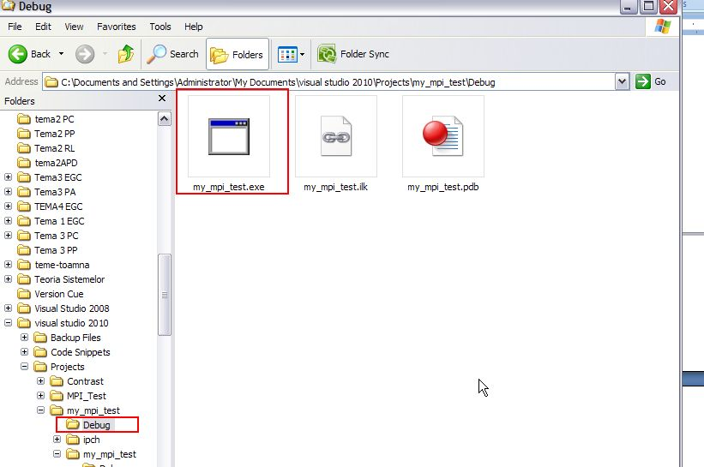
- This is the file you need to pass to wmpiexec in order to run your program, you can either copy it to a test folder or you can give this path to wmpiexec.
- Open wmpiexec (Start -> Applications -> MPICH2 -> wmpiexec.exe). Browse for your executable and add it.
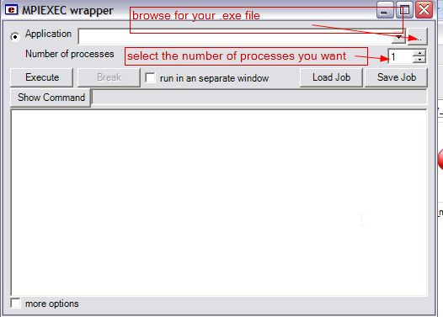
- Select the number of processes and then click ”Execute”.
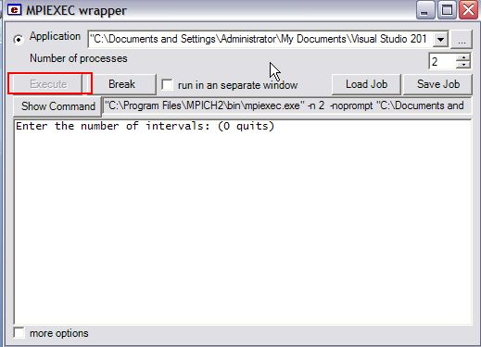

4.2 Running MPI applications on a group of Windows PC`s
The computer must be in the same LAN network. You will address a computer using it`s IP.
Install MPICH2 on all computers.
Create a common user account on every computer, with the same password. The user accounts must be administrative.
On each computer
- right-click on My Computer -> Properties -> Advanced Tab -> Environment Variables, find Path in System Variables, click edit and add ;C:\Program Files\MPICH2\bin or the folder in which you instaled MPICH2 at the end, don`t forget the semicolon.
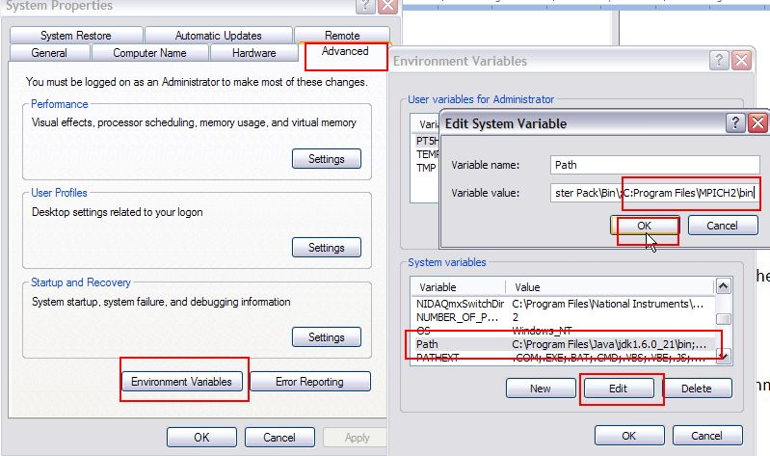
- The application you are running must be in the same folder on each computer. On the master node share that folder.
- Turn off the Windows Firewall.

- To see if the computers were added in the group, open wmpiconfig(Start -> MPICH2-> wmpiconfig.exe)
- You can then scan for hosts. If the settings were done right, the computers which you have configured will appear.
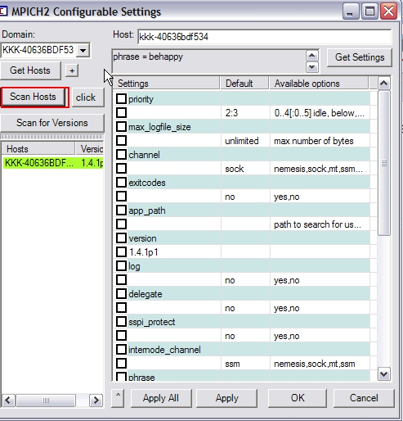
Execution
- For the actual execution you will use Windows Command Prompt. Open Start -> Run and type in cmd.
- Go to the [location of MPICH2]\bin using cd. Example: cd C:\Program Files\MPICH2\bin .
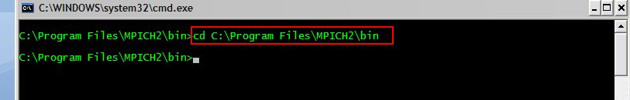
- Here you have the wmpiexec.exe.
mpiexec usage :
mpiexec –hosts <n host1 host2 .... hostn> application.exe
Example
mpiexec –hosts 2 102.168.0.1 192.168.0.2 application.exe
