Ahmad El-Falou
For Achievement in First Year – Biomedical Engineering
Department of Electrical and Computer Engineering Award
For Academic Excellence - $500
Where there's a will, there's a way. Hard work is choosing to take that path.
A special thanks to all those who helped and supported me.

Siavash Jafarpour
For Achievement in First Year – Biomedical Engineering
Pierre Lassonde Entrance Award in Engineering
For Academic Excellence - $6,000
It means a lot to me to receive this award, it pretty much serves as a boost and pumps me and tells me that I am on the right track and I should keep up the good work. If you have dreams follow them."Nothing is 'impossible', the word itself says 'I’m possible'."

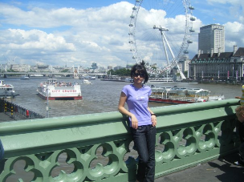
Nazanin Javidneshan
For Achievement in First Year – Biomedical Engineering
Charles A. Root Award
For Academic Excellence - $2, 200
I'm delighted and honored to receive this scholarship, as it allows me to work and study harder and focus on my work much more to achieve future scholarships.

NO PHOTO

Renji Syamala Kumar
For Achievement in First Year – Computer Engineering
Jack Roy Longstaffe Memorial Scholarship
For Academic Excellence - $1, 000
I really thank and appreciate the jury for selecting me for the honorable award.

NO PHOTO
Prateek Mohan
For Achievement in First Year – Computer Engineering
Department of Electrical and Computer Engineering Award
For Academic Excellence - $500

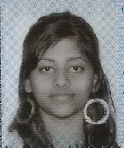
Sai Durga Kalluri
For Achievement in First Year – Computer Engineering
Aditya Jha Award - $2,832
I would like to thank the Department of Electrical and Computer Engineering for
providing these opportunities for students. I am very glad that I have received this award
because this award is helping me in a deserving situation.

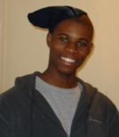
Elmer Atagu
For Achievement in First Year – Electrical Engineering
Jack Roy Longstaffe Memorial Scholarship
For Academic Excellence - $1,000
Suffice it to say, this award reiterates the fact that success is within the reach of anyone who works hard. This award serves me well as a motivating factor to continue to work relentlessly, pursuing success wherever it may be found. This award means a lot to me and I am truly delighted to have been selected as a recipient.

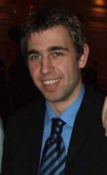
Igor Ivanecky
For Achievement in First Year – Electrical Engineering
Dimitri Klimow Memorial Scholarship
For Academic Excellence - $902
Being selected for this award for academic excellence is a special achievement for me because I was not always ranked high academically. Becoming focused on my studies has paid off and this award acknowledges that success and will hopefully provide inspiration for others to strive to achieve their best.

Furong Liu
For Achievement in First Year – Electrical Engineering
Pierre Lassonde Entrance Award in Engineering - $6,000
It is my great honor to be selected as a scholarship recipient for the Pierre Lassonde Entrance Award in Engineering. I am so delighted and I still cannot believe I really can obtain this scholarship. This highly regarded honor from Ryerson University is really an encouragement and recognition of my previous endeavors and once again makes me believe that my effort really pays off. For me, this acceptance to be one of the outstanding individuals adds a new milestone to my walk of life. It will most definitely serve as a great motivation to my future endeavors and always propels me to take on further challenges, experience uncharted territory. I am very happy to be part of the Ryerson community and I really want to express my gratefulness to Ryerson University to their recognition and their efforts to help us discover more about ourselves. Thank you very much.

NO PHOTO
Guangyu Zhu
For Achievement in First Year – Electrical Engineering
James H. Rattray Memorial Award
For General Proficiency - $200

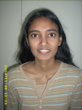
Thavisha Assalaarachchi
For Achievement in Second Year – Computer Engineering
- Ontario Professional Engineers Foundation for Education Undergraduate Scholarship
For Academic Excellence - $1, 250
- Michael Stechly Memorial Award
For Academic Excellence - $934
I was very happy to receive these two awards for reasons: it showed me that I am capable of succeeding in the field of Computer Engineering and thanks to the financial help my student debt will blessed.

Rares Raducu
For Achievement in Second Year – Computer Engineering
- Genivar Scholarship
For Academic Excellence - $2,000
- Rockwell Automation Award
For General Proficiency - $750
I am honored to receive the Genivar Scholarship and the Rockwell Automation Award. Receiving these scholarships is the beginning of my dream; it is not only the materialization of my ideas but also the roots with which my dream begins. I say roots because even though I’ve been dreaming ever since I first laid my hands on parts and built my first robot, I wasn't sufficiently motivated. It will help me continue studying and to advance my knowledge to pursue my dream of designing artificial limbs for disabled people. I would like to thank you for offering me this opportunity, and also my fiancée for always supporting and believing in me.

Nasim Zoubeiri
For Achievement in Second Year – Computer Engineering
Aditya Jha Diversity Award - $2,832
Receiving the Aditya Jha Diversity award has meant a lot to me. I very much appreciate those affiliates of Ryerson University who are conscious of the financial needs of students and help benefit their lives. University is a very challenging passage in the life of any student, which molds students into the people they will become. Receiving the Aditya Jha Diversity award has reassured me that I'm not going through this alone.

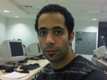
Mohammad Farrokhi Aghdam
For Achievement in Second Year – Electrical Engineering
Jack Roy Longstaffe Memorial Scholarship
For Academic Excellence - $1,000
This award is so important for me and will give me more motivation to study as well.

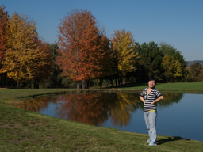
Ling Zhao
For Achievement in Second Year – Electrical Engineering
AZCAR Award
For Academic Excellence - $5,000
This award means a lot for me, it inspires me when I feel really exhausted after such a long time of continuous hard study. It will stand out when I look for an internship position, even a job offer after graduation. It mitigates the economic stress for my family. In short, this award excites me very much and it encourages me to study even harder than before.

Mohammad Fawaz
For Achievement in Third year – Computer Engineering
Walter Anderson Awar in RF Communication
For Academic Excellence - $1,000
I’m really honored to be selected for this prestigious award. My professors and friends are to thank for helping me along the way and for making these last three years very enjoyable. I will continue to work hard this year and with everyone’s continued support I know I can do well.

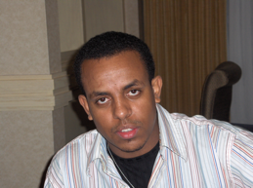
Kebede Asfaw
For Achievement in Third Year Electrical Engineering
Department of Electrical and Computer Engineering Award
For Academic Excellence - $500
To be selected by the department for this award is such a great honor to me. It motivates me to work even harder and achieve more. I would like to thank the department for recognizing and rewarding my hard work.

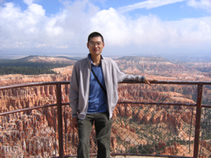
Min Bei
For Achievement in Third Year Electrical Engineering
- Ingenium Group Jack Leman Memorial Award
For Academic Excellence - $2,500
- Ontario Professional Engineers Foundation for Education Undergraduate
Studies Scholarship for Academic Excellence - $1,250
- Frank Juranka Memorial Scholarship
For General Proficiency and Excellence in Energy Conversion - $210
Thank awards Committee for selecting me as the scholarships recipient. It is my pleasure and I am very happy to hear I was selected. Receiving these awards tells me all my hard work in the past academic year was worthy and recognized. Nevertheless, there is many other people stand by me all the time to help me get to this achievement. It was Ryerson University and the Department of Electrical and Computer Engineering to give me the opportunity to learn and prove myself in the Electrical Engineering program. It was the professors to lead me into the world of Electrical Engineering; and it was my peer schoolmates to share the toughness and happiness in my study. I would like to thank all the people who helped me again and please share my happiness and excitement for receiving the awards.

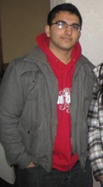
Bikramjit Johal
For Achievement in Third Year Electrical Engineering
IEEE Toronto Section Scholarship
For Academic Excellence - $2,000
I'd like to thank the IEEE Toronto Section and the department for giving me this scholarship. I'd also like to express my gratitude to the wonderful professors I had last year. They made my courses interesting and as a result I learned a lot of valuable concepts. I feel very honored to receive this scholarship. Last year was my third year of Electrical Engineering and I found it quite challenging. However, I tried my best, and it really paid off in the end.

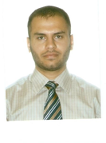
Abdulhkem Klif
For Achievement in Third Year Electrical Engineering
Department of Electrical and Computer Engineering Award
For Academic Excellence - $500
I am very glad to receive this award and this will give me more motivation to continue my successful achievements. I appreciate the department’s special encouragements towards hardworking students offering valuable awards.

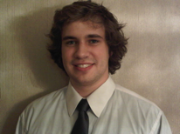
Ryan Snow
For Achievement in Third Year Electrical Engineering
AZCAR Award
For Academic Excellence - $5,000
Throughout the course of my undergraduate career, I have had the privilege of working with some talented and bright individuals. In considering my peers and the competition they have provided, I can honestly say that receiving this award is a great honor and very humbling. Being in Electrical Engineering at Ryerson University has afforded me the opportunity to apply my knowledge and understanding in a more complete way. It is this unique opportunity that has provided me the motivation to work so hard. Thank you to Ryerson, the Awards Committee, and to every one of my lab partners and friends who have supported me, to allow me to get to where I am today.

NO PHOTO
James Cancilla
For Achievement in Fourth Year Computer Engineering
Department of Electrical and Computer Engineering Award
For Excellence in Thesis Project Performance - $170

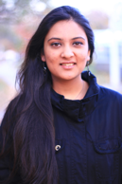
Nazuk Jain
For Achievement in Fourth Year Computer Engineering
IEEE Toronto Section, Wallas Scholarship
For Academic Excellence - $2,000
It’s a matter of great honor for me to be presented with this prestigious award. IEEE is a recognized engineering community world over, and an award from such an organization makes it all the more valuable. Awards like these encourage me to work harder and strive for excellence. I am very thankful to the award community for selecting me for this award.

Anna Surtayeva
For Achievement in Fourth Year Computer Engineering
Ed Towgood Award
For Excellence in Thesis Project Performance - $173
Reception of this award is a great honor for me, and this achievement would not be possible without the exceptional experience at Ryerson University’s Electrical Engineering program. Undergraduate studies gave me the essential background and experience that allows me to succeed in the current competitive market. This engineering background knowledge allowed me to successfully complete the design project that received the Ed Towgood Award, and obtain employment with the MDA Space Missions Corporation as junior engineer within weeks of the graduation.

NO PHOTO
Pouria Ataei
For Achievement in Fourth Year – Electrical Engineering
Department of Electrical and Computer Engineering Award
For Academic Excellence - $500

NO PHOTO
Joseph Carullo
For Achievement in Fourth Year – Electrical Engineering
David Platnick Memorial Award
For General Proficiency and Excellence in Design Project Performance - $499

NO PHOTO
Dima Ostrovsky
For Achievement in Fourth Year – Electrical Engineering
Department of Electrical and Computer Engineering Award
For Academic Excellence - $500

